Analysis Q1 of KAGGLE project

At first step we should import two different set of data, according to Video and information in the KAGGLE site. These two set same 79 explanatory variables, but train set data is also including SalePrice as response variable, but the test data is not containing this variable. For improting these two sets of data with CSV format we can use different methods in SAS, but I use the import command directly from file tab in the software according to the Figure 1:

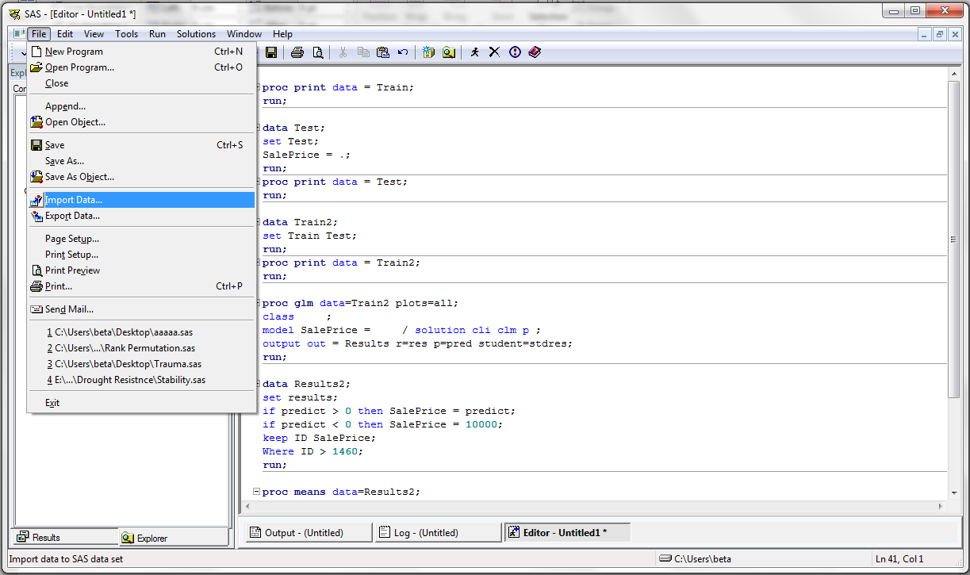

Figure 1. Import command for importing data into SAS software.

After importing these two data set (Train and Test), I use proc print to be sure that the data in both sets are imported properly:

**proc** **print** data = Train;

**run**;

**proc** **print** data = Test;

**run**;

Since Test set is not containing response rvariable (SalePrice), I made a new variable with this name where all of it values are dot (.) and we can latter use it for predicting these value in SalePrice:

**data** Test;

set Test;

SalePrice = **.**;

**run**;

**proc** **print** data = Test;

**run**;

According to the Video, I Merged these two data set that have the same variables but different values with each other using the following SAS code:

**data** Train2;

set Train Test;

**run**;

**proc** **print** data = Train2;

**run**;

the final data set I named it as Train2 is containing both Train and Test data sets, but the values for SalePrice in test set is equal to “.”.

id this stage, we should exclude all data for three neighborhood containing “Edwards”, “NAmes”, and “brkSide”. Therefore, at first I sorted the data by Neighborhood variable and the selected all data for these three neighborhoods. Also, I just kept applicable variable in the Question 1 of the project for saving time, meaning that I kept id, Neighborhood, GrLIvArea, and SalePrice variables. This new data set is called Q1:

**proc** **sort** data = Train2 out=SrtTrain;

by Neighborhood;

**run**;

**Data** Q1;

set SrtTrain;

logGrLIvArea = log(GrLIvArea);

LogSalePrice = Log(SalePrice);

KEEP id Neighborhood GrLIvArea SalePrice;

if (Neighborhood = 'NAmes') or (Neighborhood = 'Edwards') or (Neighborhood = 'BrkSide');

**run**;

At nest stage I transformed two numerical variables (SalePrice and grLivingArea) using log function by following SAS code:

**Data** Q1;

set Q1;

logGrLIvArea = log(GrLIvArea);

LogSalePrice = Log(SalePrice);

**run**;

**proc** **sort** data = Q1 out=Q1;

by id;

**run**;

**proc** **print** data = Q1;

**run**;

So, the final data set is containing id, Neighborhood, GrLivingArea, SalePrice, Log GrLivingArea, and Log SalePrice (Figure 2).

**Data** Q1;

set Q1;

logGrLIvArea = log(GrLIvArea);

LogSalePrice = Log(SalePrice);

**run**;

**proc** **sort** data = Q1 out=Q1;

by id;

**run**;

**proc** **print** data = Q1;

**run**;

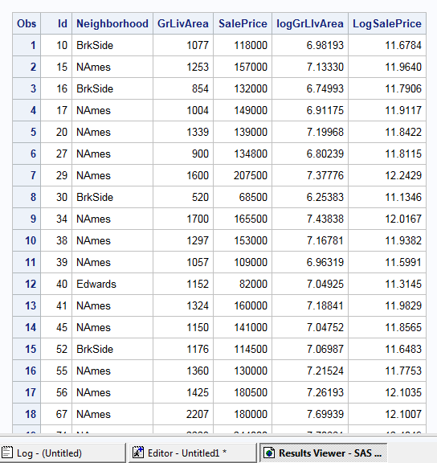

Figure 2. Final data set entitled Q1 for question 1 in the project.

For this question there are different combinations to be used for modeling the SalePrice:

1. Model with not transformation, no outlier, and also no interaction.
2. Model with Log transformation for SalePrice and no transformation for GrLivingAre, no outlier, and also no interaction (Log-Linear transformation model).
3. Model with Log transformation for GrLivingAre and no transformation for SalePrice, no outlier, and also no interaction (Linear-Log transformation model).
4. Model with Log transformation for both GrLivingAre and SalePrice, no outlier, and also no interaction (Linear-Log transformation model).

Using the following code, I just carried out all of these combinations:

*no transformation, no outlier, no interaction effect;

**proc** **glm** data=Q1 plots=all;

class Neighborhood ;

model SalePrice = GrLIvArea Neighborhood / solution ;

output out = Results1 r=res p=pred student=stdres;

**run**;

*log-linear model, no outlier, no interaction effect;

**proc** **glm** data=Q1 plots=all;

class Neighborhood ;

model LogSalePrice = GrLIvArea Neighborhood / solution ;

output out = Results3 r=res p=pred student=stdres;

**run**;

*linear-log model, no outlier, no interaction effect;

**proc** **glm** data=Q1 plots=all;

class Neighborhood ;

model SalePrice = LogGrLIvArea Neighborhood / solution ;

output out = Results4 r=res p=pred student=stdres;

**run**;

*log-log model, no outlier, no interaction effect;

**proc** **glm** data=Q1 plots=all;

class Neighborhood ;

model LogSalePrice = LogGrLIvArea Neighborhood / solution ;

output out = Results2 r=res p=pred student=stdres;

**run**;

Figure 3, Figure 4, Figure 5, and Figure 6 are presenting the results for the above models, respectively:

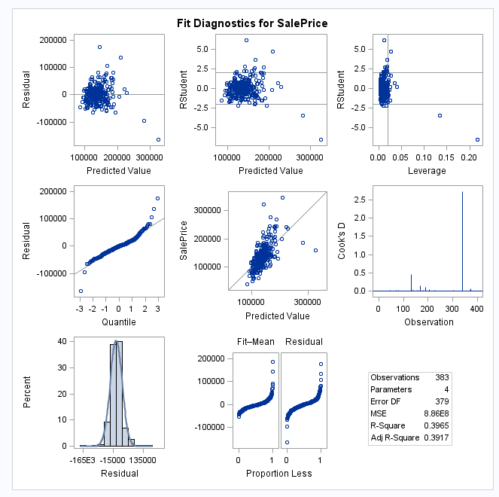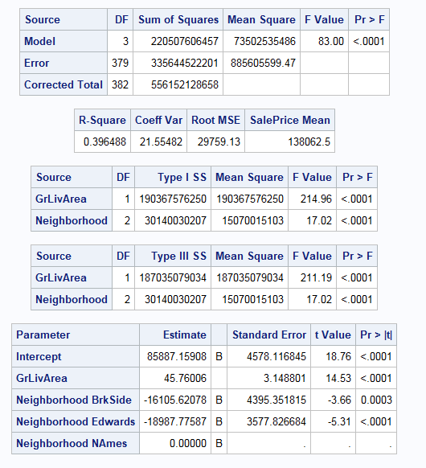

Figure 3. Result of the model with no transformation, no outlier, and no interaction effect.

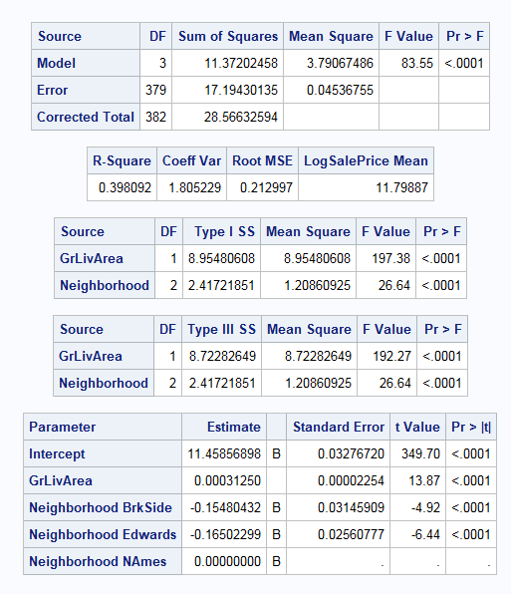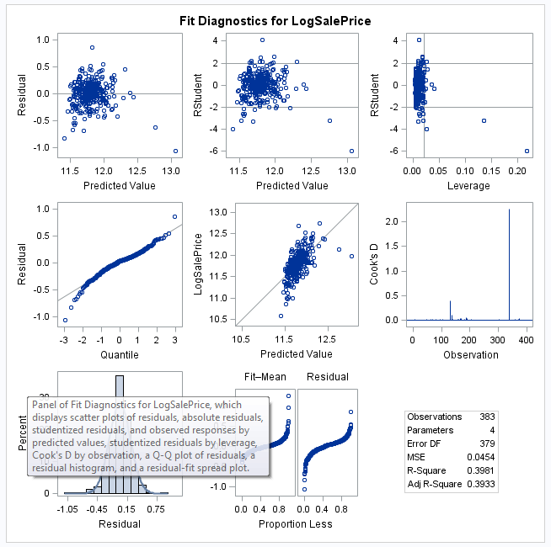

Figure 4. Result of the Log-Linear model, no outlier, and no interaction effect.

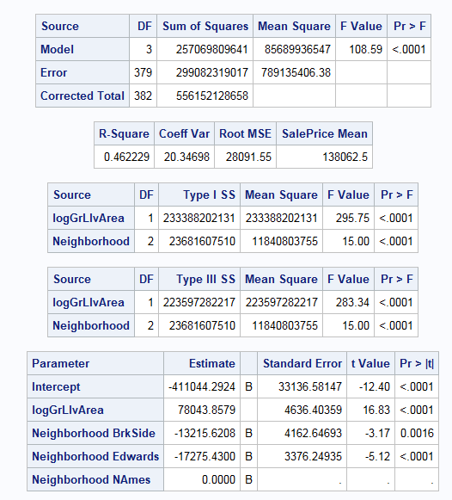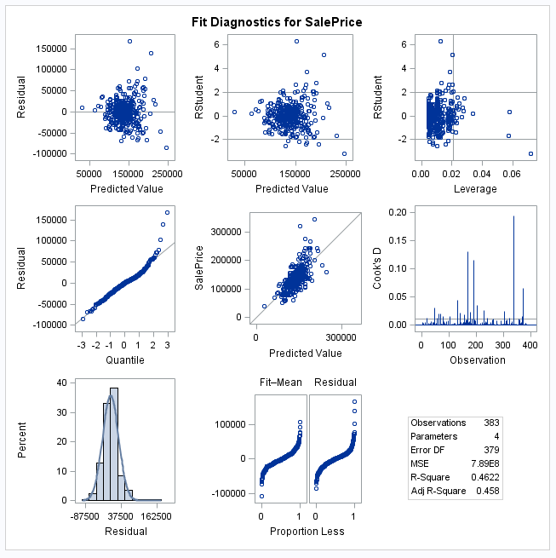

Figure 5. Result of the Linear-Log model, no outlier, and no interaction effect.

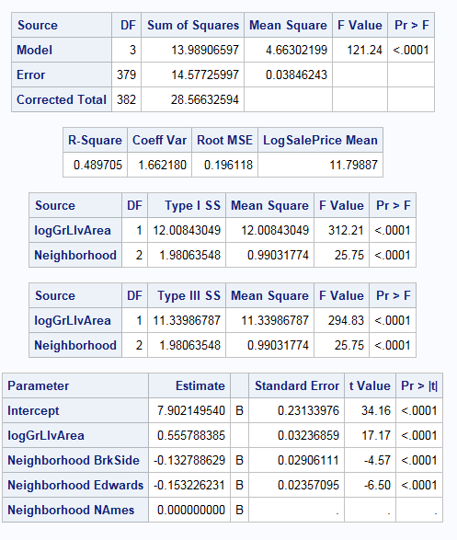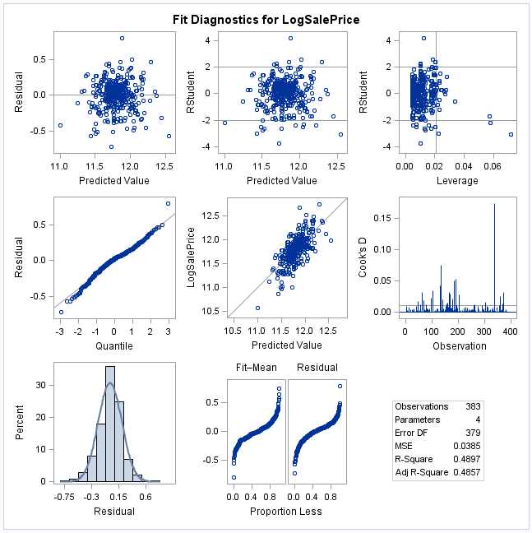

Figure 6. Result of the Log-Log model, no outlier, and no interaction effect.

All of the results here are indicating possible outliers in these data. Hence, I used the following code for reaching residuals and distinguishing the possible outlier among data.

**Proc** **sort** data = results2 out = rr;

by res;

**proc** **print** data=rr;

**run**;

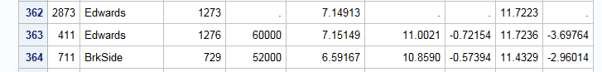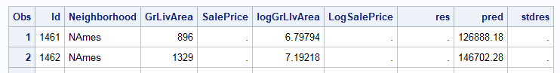

Figure 7. Screening possible outlier in data.

These results indicate at least two possible outliers with studentized residuals higher |5|, (id=411, and id =725). Please note that I used the output of the Log-Log model for distinguishing the outliers.

After recognizing possible outliers, I just used the following code for excluding these two values from the analysis and then again I ran these models for finding the best one. This time I just ran the two best models which are no transformation and log-log transformation models.

**data** Q1_2;

set Q1;

if (id = **725**) or (id = **411**) then delete;

**run**;

*no transformation and removed outlier = 2;

**proc** **glm** data=Q1_2 plots=all;

class Neighborhood ;

model SalePrice = GrLIvArea Neighborhood / solution ;

output out = Results1 r=res p=pred student=stdres;

**run**;

*log-log model and removed outlier = 2;

**proc** **glm** data=Q1_2 plots=all;

class Neighborhood ;

model LogSalePrice = LogGrLIvArea Neighborhood / solution ;

output out = Results2 r=res p=pred student=stdres;

**run**;

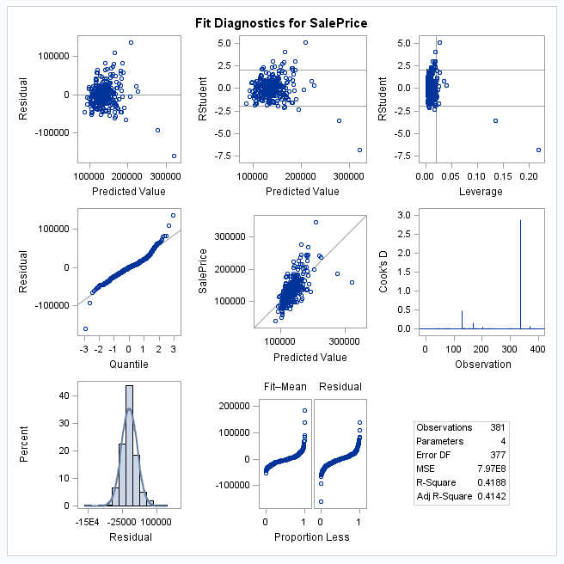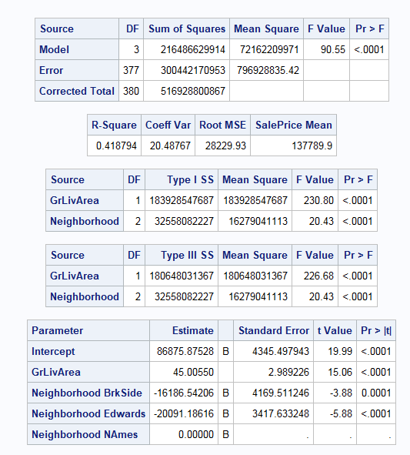

Figure 8. output of no transformation model with removed two outliers and no interaction.

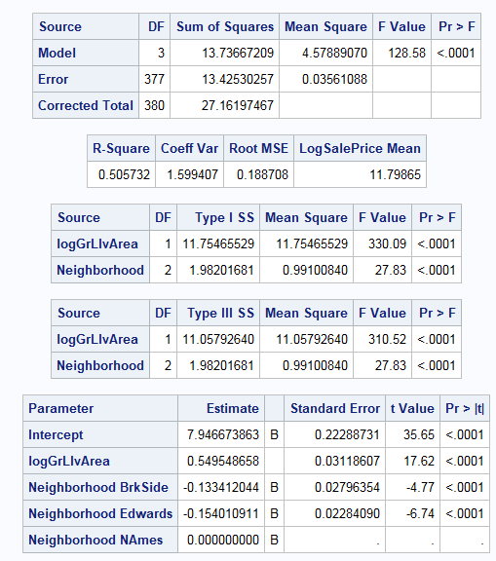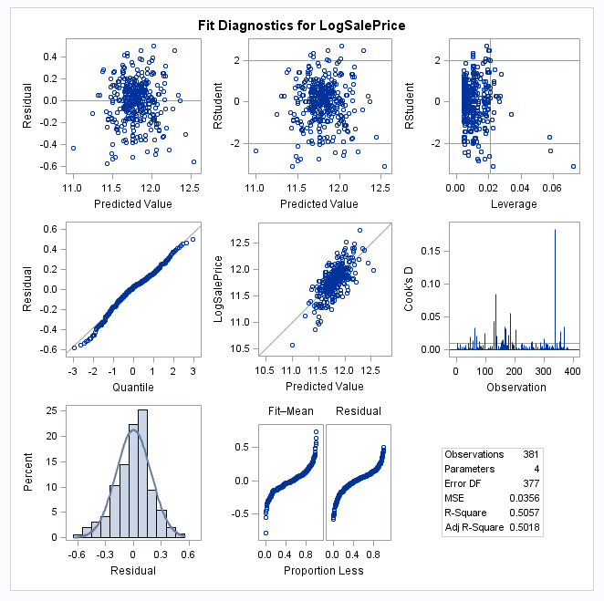

Figure 9. Output of Log-Log transformation model with removed two outliers and no interaction.

Residual in these two models are propperly fitted with normal distribution and show no more outliers, but there is still a great problem with these two models which is low r-sqaure. However the r-square in log-log model is higher than the original data modeling, but this r-square is however low. Therefore, I tested these models with interactions according to the following code:

*no transformation & removed outlier = 2 & Interaction;

**proc** **glm** data=Q1_2 plots=all;

class Neighborhood ;

model SalePrice = GrLIvArea | Neighborhood / solution clparm;

output out = Results1 r=res p=pred student=stdres;

**run**;

*log-log model & removed outlier = 2 & Interaction;

**proc** **glm** data=Q1_2 plots=all;

class Neighborhood ;

model LogSalePrice = LogGrLIvArea | Neighborhood / solution clparm ;

output out = Results r=res p=pred student=stdres;

**run**;

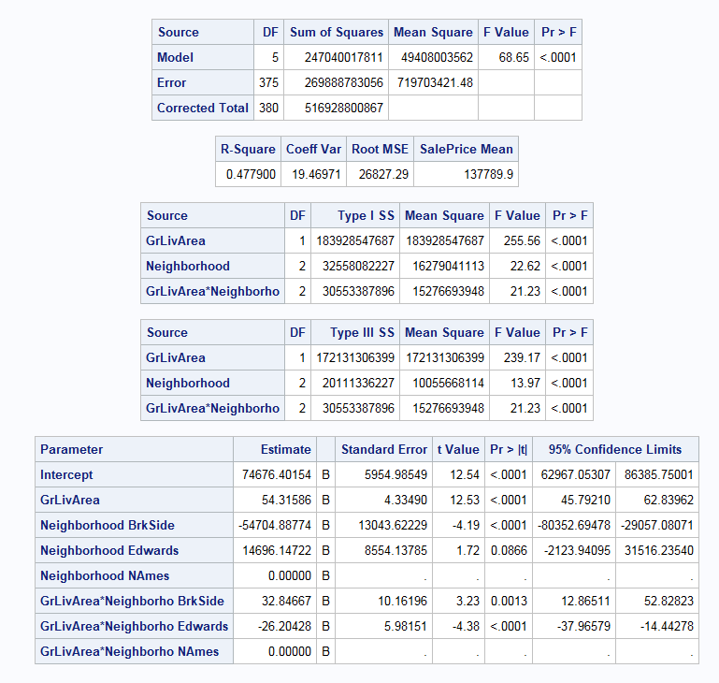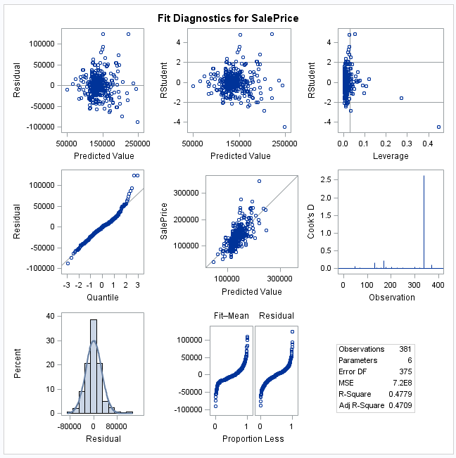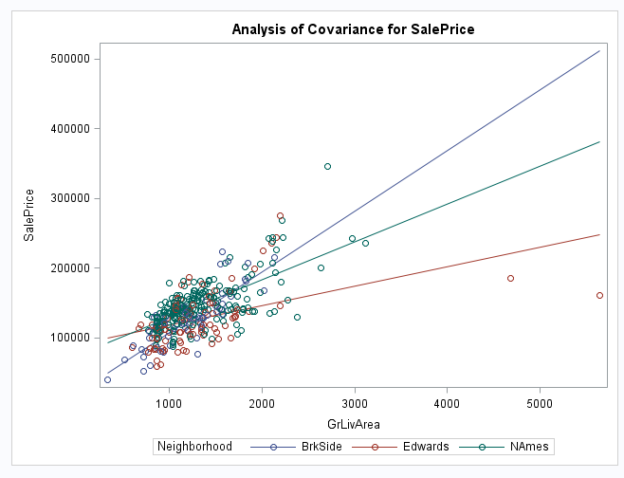

Figure 10. No transformation model with two removed outliers and interaction effects.

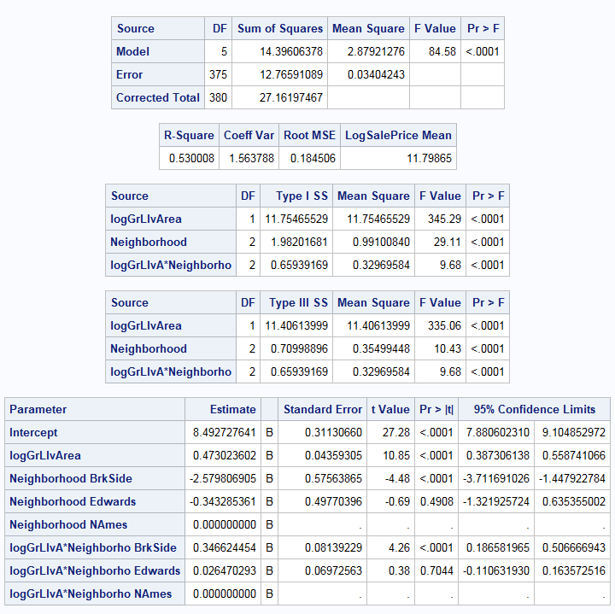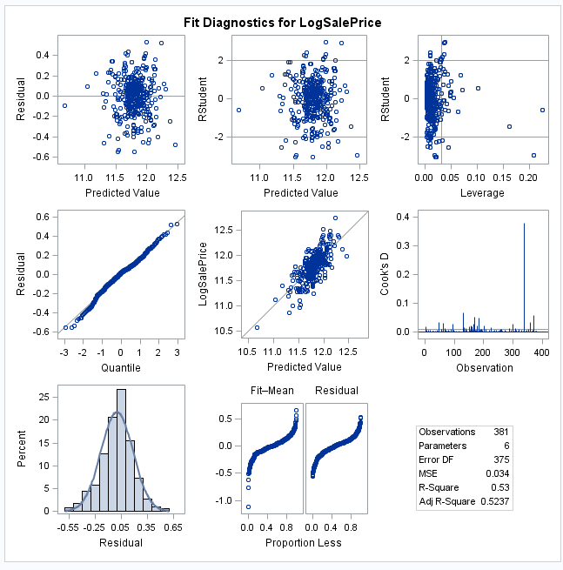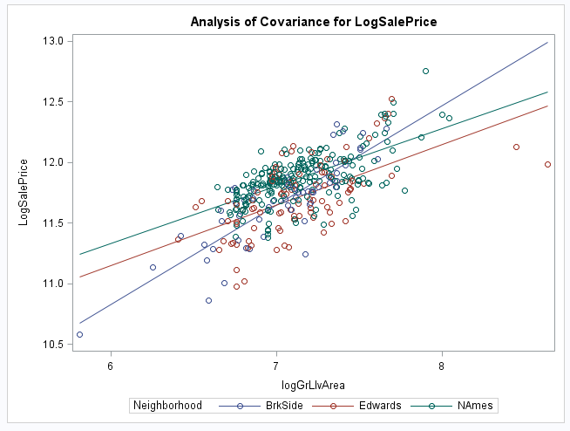

Figure 11. Log-Log transformation model with two removed outliers and interaction effects.

The output of the no transformation and log-log models indicates that interaction effect should be included in the models because the lines for each Neighborhood crossed one another. Also, residuals showed no problem with distriution or outlier or other possible probels. The r-square in log-log moel is 0.53 which is clealry hgiher than that for original data.

All in all, I think that the best model for modeling these data is Log-Log transformed method, with two removed outliers (id =411, and id=725) and including interaction efects in the model.

In this stage, we can go farther and predict all SalePrice in the test set by simply using following code:

*log-log model & removed outlier = 2 & Interaction;

**proc** **glm** data=Q1_2 plots=all;

class Neighborhood ;

model LogSalePrice = LogGrLIvArea | Neighborhood / solution clparm ;

output out = Results r=res p=pred student=stdres;

**run**;

**proc** **print** data = Results;

**run**;

| **Obs** | **Id** | **Neighborhood** | **GrLivArea** | **SalePrice** | **logGrLIvArea** | **LogSalePrice** | **res** | **pred** | **stdres** |
| --- | --- | --- | --- | --- | --- | --- | --- | --- | --- |
| **1** | 10 | BrkSide | 1077 | 118000 | 6.98193 | 11.6784 | 0.04279 | 11.6356 | 0.23399 |
| **2** | 15 | NAmes | 1253 | 157000 | 7.13330 | 11.9640 | 0.09706 | 11.8669 | 0.52721 |
| **3** | 16 | BrkSide | 854 | 132000 | 6.74993 | 11.7906 | 0.34507 | 11.4455 | 1.89754 |
| **4** | 17 | NAmes | 1004 | 149000 | 6.91175 | 11.9117 | 0.14955 | 11.7621 | 0.81352 |
| **5** | 20 | NAmes | 1339 | 139000 | 7.19968 | 11.8422 | -0.05612 | 11.8983 | -0.30486 |
| **6** | 27 | NAmes | 900 | 134800 | 6.80239 | 11.8115 | 0.10113 | 11.7104 | 0.55103 |
| **7** | 29 | NAmes | 1600 | 207500 | 7.37776 | 12.2429 | 0.26030 | 11.9826 | 1.41630 |
| **8** | 30 | BrkSide | 520 | 68500 | 6.25383 | 11.1346 | 0.09573 | 11.0389 | 0.54754 |
| **9** | 34 | NAmes | 1700 | 165500 | 7.43838 | 12.0167 | 0.00547 | 12.0113 | 0.02978 |
| **10** | 38 | NAmes | 1297 | 153000 | 7.16781 | 11.9382 | 0.05492 | 11.8833 | 0.29835 |
| **11** | 39 | NAmes | 1057 | 109000 | 6.96319 | 11.5991 | -0.18738 | 11.7865 | -1.01868 |
| **12** | 40 | Edwards | 1152 | 82000 | 7.04925 | 11.3145 | -0.35603 | 11.6705 | -1.94007 |
| **13** | 41 | NAmes | 1324 | 160000 | 7.18841 | 11.9829 | 0.08991 | 11.8930 | 0.48844 |
| **14** | 45 | NAmes | 1150 | 141000 | 7.04752 | 11.8565 | 0.03015 | 11.8264 | 0.16379 |
| **15** | 52 | BrkSide | 1176 | 114500 | 7.06987 | 11.6483 | -0.05940 | 11.7077 | -0.32478 |
| **16** | 55 | NAmes | 1360 | 130000 | 7.21524 | 11.7753 | -0.13042 | 11.9057 | -0.70855 |
| **17** | 56 | NAmes | 1425 | 180500 | 7.26193 | 12.1035 | 0.17570 | 11.9278 | 0.95480 |
| **18** | 67 | NAmes | 2207 | 180000 | 7.69939 | 12.1007 | -0.03401 | 12.1347 | -0.18640 |
| **19** | 71 | NAmes | 2223 | 244000 | 7.70661 | 12.4049 | 0.26679 | 12.1381 | 1.46260 |
| **20** | 74 | NAmes | 1086 | 144900 | 6.99026 | 11.8838 | 0.08452 | 11.7993 | 0.45936 |
| **21** | 77 | NAmes | 952 | 135750 | 6.85857 | 11.8186 | 0.08158 | 11.7370 | 0.44409 |
| **22** | 78 | BrkSide | 1285 | 127000 | 7.15851 | 11.7519 | -0.02844 | 11.7804 | -0.15566 |
| **23** | 81 | NAmes | 2142 | 193500 | 7.66950 | 12.1730 | 0.05245 | 12.1206 | 0.28723 |
| **24** | 84 | NAmes | 1065 | 126500 | 6.97073 | 11.7480 | -0.04205 | 11.7900 | -0.22859 |
| **25** | 91 | NAmes | 1040 | 109900 | 6.94698 | 11.6073 | -0.17149 | 11.7788 | -0.93243 |
| **26** | 92 | NAmes | 1235 | 98600 | 7.11883 | 11.4988 | -0.36127 | 11.8601 | -1.96244 |
| **27** | 98 | Edwards | 960 | 94750 | 6.86693 | 11.4590 | -0.12044 | 11.5794 | -0.65808 |
| **28** | 99 | Edwards | 835 | 83000 | 6.72743 | 11.3266 | -0.18316 | 11.5098 | -1.00490 |
| **29** | 100 | NAmes | 1225 | 128950 | 7.11070 | 11.7672 | -0.08907 | 11.8563 | -0.48386 |
| **30** | 111 | Edwards | 1855 | 136900 | 7.52564 | 11.8270 | -0.08145 | 11.9085 | -0.44682 |
| **31** | 118 | Edwards | 1125 | 155000 | 7.02554 | 11.9512 | 0.29252 | 11.6587 | 1.59433 |
| **32** | 123 | NAmes | 1080 | 136000 | 6.98472 | 11.8204 | 0.02375 | 11.7967 | 0.12907 |
| **33** | 129 | NAmes | 1348 | 155000 | 7.20638 | 11.9512 | 0.04967 | 11.9015 | 0.26982 |
| **34** | 130 | NAmes | 1053 | 150000 | 6.95940 | 11.9184 | 0.13370 | 11.7847 | 0.72690 |
| **35** | 131 | NAmes | 2157 | 226000 | 7.67647 | 12.3283 | 0.20441 | 12.1239 | 1.11956 |
| **36** | 133 | NAmes | 1327 | 150750 | 7.19068 | 11.9234 | 0.02929 | 11.8941 | 0.15912 |
| **37** | 137 | NAmes | 1214 | 143000 | 7.10168 | 11.8706 | 0.01861 | 11.8520 | 0.10110 |
| **38** | 141 | NAmes | 864 | 115000 | 6.76157 | 11.6527 | -0.03842 | 11.6911 | -0.20954 |
| **39** | 143 | NAmes | 1385 | 166000 | 7.23346 | 12.0197 | 0.10542 | 11.9143 | 0.57279 |
| **40** | 146 | Edwards | 1709 | 130000 | 7.44366 | 11.7753 | -0.09222 | 11.8675 | -0.50459 |
| **41** | 147 | BrkSide | 875 | 105000 | 6.77422 | 11.5617 | 0.09632 | 11.4654 | 0.52914 |
| **42** | 150 | BrkSide | 1344 | 115000 | 7.20341 | 11.6527 | -0.16449 | 11.8172 | -0.90110 |
| **43** | 156 | Edwards | 1096 | 79000 | 6.99942 | 11.2772 | -0.36841 | 11.6456 | -2.00845 |
| **44** | 157 | NAmes | 1040 | 109500 | 6.94698 | 11.6037 | -0.17513 | 11.7788 | -0.95226 |
| **45** | 166 | Edwards | 1355 | 127500 | 7.21156 | 11.7559 | 0.00430 | 11.7516 | 0.02344 |
| **46** | 172 | NAmes | 1656 | 215000 | 7.41216 | 12.2784 | 0.27954 | 11.9989 | 1.52171 |
| **47** | 174 | NAmes | 1362 | 163000 | 7.21671 | 12.0015 | 0.09510 | 11.9064 | 0.51670 |
| **48** | 176 | Edwards | 2158 | 243000 | 7.67694 | 12.4008 | 0.41679 | 11.9840 | 2.30127 |
| **49** | 183 | Edwards | 1340 | 120000 | 7.20042 | 11.6952 | -0.05076 | 11.7460 | -0.27661 |
| **50** | 185 | BrkSide | 1252 | 127000 | 7.13250 | 11.7519 | -0.00712 | 11.7591 | -0.03893 |
| **51** | 192 | NAmes | 1479 | 184000 | 7.29912 | 12.1227 | 0.17731 | 11.9454 | 0.96385 |
| **52** | 194 | Edwards | 1709 | 130000 | 7.44366 | 11.7753 | -0.09222 | 11.8675 | -0.50459 |
| **53** | 198 | NAmes | 3112 | 235000 | 8.04302 | 12.3673 | 0.07007 | 12.2973 | 0.38975 |
| **54** | 201 | Edwards | 1121 | 140000 | 7.02198 | 11.8494 | 0.19252 | 11.6569 | 1.04932 |
| **55** | 208 | NAmes | 1100 | 141000 | 7.00307 | 11.8565 | 0.05117 | 11.8053 | 0.27810 |
| **56** | 210 | NAmes | 1092 | 145000 | 6.99577 | 11.8845 | 0.08260 | 11.8019 | 0.44892 |
| **57** | 211 | Edwards | 864 | 98000 | 6.76157 | 11.4927 | -0.03408 | 11.5268 | -0.18678 |
| **58** | 212 | Edwards | 1212 | 186000 | 7.10003 | 12.1335 | 0.43764 | 11.6959 | 2.38423 |
| **59** | 216 | NAmes | 1236 | 134450 | 7.11964 | 11.8089 | -0.05154 | 11.8605 | -0.27994 |
| **60** | 224 | NAmes | 864 | 97000 | 6.76157 | 11.4825 | -0.20864 | 11.6911 | -1.13782 |
| **61** | 231 | NAmes | 1194 | 148000 | 7.08506 | 11.9050 | 0.06084 | 11.8441 | 0.33049 |
| **62** | 240 | Edwards | 1487 | 113000 | 7.30452 | 11.6351 | -0.16286 | 11.7980 | -0.88844 |
| **63** | 248 | NAmes | 1375 | 140000 | 7.22621 | 11.8494 | -0.06150 | 11.9109 | -0.33413 |
| **64** | 251 | BrkSide | 1306 | 76500 | 7.17472 | 11.2450 | -0.54862 | 11.7937 | -3.00354 |
| **65** | 254 | NAmes | 1302 | 158000 | 7.17166 | 11.9704 | 0.08526 | 11.8851 | 0.46314 |
| **66** | 255 | NAmes | 1314 | 145000 | 7.18083 | 11.8845 | -0.00494 | 11.8894 | -0.02684 |
| **67** | 261 | NAmes | 1382 | 176000 | 7.23129 | 12.0782 | 0.16494 | 11.9133 | 0.89619 |
| **68** | 270 | Edwards | 1113 | 148000 | 7.01481 | 11.9050 | 0.25167 | 11.6533 | 1.37179 |
| **69** | 274 | NAmes | 1632 | 139000 | 7.39756 | 11.8422 | -0.14972 | 11.9919 | -0.81484 |
| **70** | 276 | BrkSide | 1548 | 205000 | 7.34472 | 12.2308 | 0.29776 | 11.9330 | 1.63901 |
| **71** | 287 | NAmes | 1734 | 159000 | 7.45819 | 11.9767 | -0.04397 | 12.0206 | -0.23952 |
| **72** | 288 | NAmes | 858 | 88000 | 6.75460 | 11.3851 | -0.30272 | 11.6878 | -1.65111 |
| **73** | 290 | BrkSide | 1396 | 153575 | 7.24137 | 11.9419 | 0.09365 | 11.8483 | 0.51355 |
| **74** | 293 | Edwards | 1716 | 131000 | 7.44775 | 11.7830 | -0.08660 | 11.8695 | -0.47389 |
| **75** | 295 | NAmes | 1644 | 167000 | 7.40489 | 12.0257 | 0.03033 | 11.9954 | 0.16511 |
| **76** | 309 | Edwards | 861 | 82500 | 6.75809 | 11.3206 | -0.20452 | 11.5251 | -1.12090 |
| **77** | 312 | NAmes | 972 | 132000 | 6.87936 | 11.7906 | 0.04373 | 11.7468 | 0.23799 |
| **78** | 325 | NAmes | 2978 | 242000 | 7.99901 | 12.3967 | 0.12025 | 12.2764 | 0.66727 |
| **79** | 328 | NAmes | 1383 | 145250 | 7.23201 | 11.8862 | -0.02743 | 11.9136 | -0.14902 |
| **80** | 329 | BrkSide | 2134 | 214500 | 7.66575 | 12.2761 | 0.07992 | 12.1961 | 0.44975 |
| **81** | 331 | NAmes | 1728 | 119000 | 7.45472 | 11.6869 | -0.33211 | 12.0190 | -1.80917 |
| **82** | 332 | NAmes | 1056 | 139000 | 6.96224 | 11.8422 | 0.05620 | 11.7860 | 0.30551 |
| **83** | 340 | NAmes | 1215 | 155000 | 7.10250 | 11.9512 | 0.09880 | 11.8524 | 0.53671 |
| **84** | 343 | NAmes | 1040 | 87500 | 6.94698 | 11.3794 | -0.39942 | 11.7788 | -2.17179 |
| **85** | 346 | BrkSide | 1577 | 140200 | 7.36328 | 11.8508 | -0.09739 | 11.9482 | -0.53655 |
| **86** | 347 | NAmes | 958 | 151500 | 6.86485 | 11.9283 | 0.18838 | 11.7400 | 1.02537 |
| **87** | 348 | NAmes | 1478 | 157500 | 7.29845 | 11.9672 | 0.02212 | 11.9451 | 0.12022 |
| **88** | 353 | Edwards | 1111 | 95000 | 7.01302 | 11.4616 | -0.19077 | 11.6524 | -1.03986 |
| **89** | 362 | BrkSide | 1505 | 145000 | 7.31655 | 11.8845 | -0.02543 | 11.9099 | -0.13979 |
| **90** | 363 | Edwards | 1922 | 198500 | 7.56112 | 12.1985 | 0.27237 | 11.9262 | 1.49619 |
| **91** | 367 | NAmes | 1394 | 159000 | 7.23993 | 11.9767 | 0.05927 | 11.9174 | 0.32207 |
| **92** | 368 | NAmes | 1431 | 165000 | 7.26613 | 12.0137 | 0.08392 | 11.9298 | 0.45608 |
| **93** | 369 | NAmes | 1268 | 132000 | 7.14520 | 11.7906 | -0.08202 | 11.8726 | -0.44551 |
| **94** | 370 | NAmes | 1287 | 162000 | 7.16007 | 11.9954 | 0.11574 | 11.8796 | 0.62872 |
| **95** | 374 | NAmes | 1319 | 123000 | 7.18463 | 11.7199 | -0.17129 | 11.8912 | -0.93049 |
| **96** | 376 | Edwards | 904 | 61000 | 6.80683 | 11.0186 | -0.53078 | 11.5494 | -2.90475 |
| **97** | 387 | Edwards | 1184 | 81000 | 7.07665 | 11.3022 | -0.38198 | 11.6842 | -2.08119 |
| **98** | 388 | Edwards | 1125 | 125000 | 7.02554 | 11.7361 | 0.07741 | 11.6587 | 0.42192 |
| **99** | 391 | Edwards | 1367 | 119000 | 7.22037 | 11.6869 | -0.06910 | 11.7560 | -0.37656 |
| **100** | 393 | NAmes | 882 | 106500 | 6.78219 | 11.5759 | -0.12496 | 11.7009 | -0.68119 |
| **101** | 394 | BrkSide | 788 | 100000 | 6.66950 | 11.5129 | 0.13336 | 11.3796 | 0.73613 |
| **102** | 396 | Edwards | 1144 | 129000 | 7.04229 | 11.7676 | 0.10055 | 11.6670 | 0.54793 |
| **103** | 398 | NAmes | 1812 | 169500 | 7.50219 | 12.0406 | -0.00083 | 12.0414 | -0.00453 |
| **104** | 419 | Edwards | 1134 | 126000 | 7.03351 | 11.7440 | 0.08140 | 11.6626 | 0.44363 |
| **105** | 420 | NAmes | 1056 | 142000 | 6.96224 | 11.8636 | 0.07755 | 11.7860 | 0.42160 |
| **106** | 425 | NAmes | 1196 | 139000 | 7.08674 | 11.8422 | -0.00269 | 11.8449 | -0.01463 |
| **107** | 428 | NAmes | 907 | 109008 | 6.81014 | 11.5992 | -0.11491 | 11.7141 | -0.62604 |
| **108** | 438 | BrkSide | 904 | 119000 | 6.80683 | 11.6869 | 0.19475 | 11.4921 | 1.06872 |
| **109** | 440 | Edwards | 1196 | 110000 | 7.08674 | 11.6082 | -0.08099 | 11.6892 | -0.44124 |
| **110** | 442 | Edwards | 1440 | 118000 | 7.27240 | 11.6784 | -0.10352 | 11.7820 | -0.56448 |
| **111** | 443 | BrkSide | 1573 | 162900 | 7.36074 | 12.0009 | 0.05475 | 11.9461 | 0.30162 |
| **112** | 446 | Edwards | 1689 | 127500 | 7.43189 | 11.7559 | -0.10576 | 11.8616 | -0.57848 |
| **113** | 447 | NAmes | 1888 | 190000 | 7.54327 | 12.1548 | 0.09391 | 12.0609 | 0.51248 |
| **114** | 460 | BrkSide | 1203 | 110000 | 7.09257 | 11.6082 | -0.11810 | 11.7263 | -0.64582 |
| **115** | 467 | NAmes | 1277 | 167000 | 7.15227 | 12.0257 | 0.14983 | 11.8759 | 0.81387 |
| **116** | 468 | NAmes | 1644 | 146500 | 7.40489 | 11.8948 | -0.10063 | 11.9954 | -0.54775 |
| **117** | 473 | Edwards | 1072 | 148000 | 6.97728 | 11.9050 | 0.27042 | 11.6346 | 1.47463 |
| **118** | 486 | NAmes | 1113 | 147000 | 7.01481 | 11.8982 | 0.08729 | 11.8109 | 0.47434 |
| **119** | 487 | NAmes | 1073 | 156000 | 6.97821 | 11.9576 | 0.16402 | 11.7936 | 0.89159 |
| **120** | 492 | NAmes | 1578 | 133000 | 7.36391 | 11.7981 | -0.17793 | 11.9760 | -0.96791 |
| **121** | 494 | NAmes | 1269 | 155000 | 7.14598 | 11.9512 | 0.07823 | 11.8729 | 0.42496 |
| **122** | 498 | BrkSide | 1820 | 184000 | 7.50659 | 12.1227 | 0.05701 | 12.0657 | 0.31667 |
| **123** | 500 | NAmes | 912 | 120000 | 6.81564 | 11.6952 | -0.02144 | 11.7167 | -0.11679 |
| **124** | 503 | Edwards | 1214 | 140000 | 7.10168 | 11.8494 | 0.15271 | 11.6967 | 0.83196 |
| **125** | 510 | NAmes | 1041 | 124500 | 6.94794 | 11.7321 | -0.04720 | 11.7793 | -0.25667 |
| **126** | 511 | NAmes | 1363 | 164900 | 7.21744 | 12.0131 | 0.10635 | 11.9067 | 0.57778 |
| **127** | 513 | NAmes | 864 | 129900 | 6.76157 | 11.7745 | 0.08341 | 11.6911 | 0.45486 |
| **128** | 522 | NAmes | 1244 | 150000 | 7.12609 | 11.9184 | 0.05486 | 11.8635 | 0.29797 |
| **129** | 523 | BrkSide | 1664 | 159000 | 7.41698 | 11.9767 | -0.01557 | 11.9922 | -0.08604 |
| **130** | 524 | Edwards | 4676 | 184750 | 8.45020 | 12.1268 | -0.24351 | 12.3703 | -1.44199 |
| **131** | 527 | NAmes | 928 | 132000 | 6.83303 | 11.7906 | 0.06564 | 11.7249 | 0.35750 |
| **132** | 529 | Edwards | 605 | 86000 | 6.40523 | 11.3621 | 0.01329 | 11.3488 | 0.07411 |
| **133** | 532 | BrkSide | 1362 | 128000 | 7.21671 | 11.7598 | -0.06830 | 11.8281 | -0.37426 |
| **134** | 533 | NAmes | 827 | 107500 | 6.71780 | 11.5852 | -0.08516 | 11.6704 | -0.46488 |
| **135** | 534 | BrkSide | 334 | 39300 | 5.81114 | 10.5790 | -0.09703 | 10.6760 | -0.59752 |
| **136** | 536 | Edwards | 1347 | 107500 | 7.20564 | 11.5852 | -0.16337 | 11.7486 | -0.89022 |
| **137** | 538 | NAmes | 864 | 111250 | 6.76157 | 11.6195 | -0.07158 | 11.6911 | -0.39033 |
| **138** | 544 | NAmes | 767 | 133000 | 6.64249 | 11.7981 | 0.16332 | 11.6348 | 0.89328 |
| **139** | 547 | BrkSide | 1635 | 210000 | 7.39940 | 12.2549 | 0.27704 | 11.9778 | 1.52898 |
| **140** | 554 | Edwards | 1126 | 108000 | 7.02643 | 11.5899 | -0.06921 | 11.6591 | -0.37723 |
| **141** | 556 | BrkSide | 1048 | 113000 | 6.95464 | 11.6351 | 0.02187 | 11.6133 | 0.11960 |
| **142** | 557 | NAmes | 1092 | 141000 | 6.99577 | 11.8565 | 0.05463 | 11.8019 | 0.29688 |
| **143** | 563 | Edwards | 996 | 108000 | 6.90375 | 11.5899 | -0.00794 | 11.5978 | -0.04333 |
| **144** | 564 | Edwards | 1674 | 185000 | 7.42297 | 12.1281 | 0.27094 | 11.8572 | 1.48170 |
| **145** | 570 | NAmes | 943 | 135960 | 6.84907 | 11.8201 | 0.08762 | 11.7325 | 0.47704 |
| **146** | 571 | NAmes | 1728 | 142600 | 7.45472 | 11.8678 | -0.15119 | 12.0190 | -0.82360 |
| **147** | 572 | NAmes | 864 | 120000 | 6.76157 | 11.6952 | 0.00414 | 11.6911 | 0.02255 |
| **148** | 575 | NAmes | 1109 | 139000 | 7.01121 | 11.8422 | 0.03303 | 11.8092 | 0.17951 |
| **149** | 576 | NAmes | 1216 | 118500 | 7.10332 | 11.6827 | -0.17010 | 11.8528 | -0.92400 |
| **150** | 581 | NAmes | 1429 | 181900 | 7.26473 | 12.1112 | 0.18210 | 11.9291 | 0.98960 |
| **151** | 583 | Edwards | 816 | 118500 | 6.70441 | 11.6827 | 0.18441 | 11.4983 | 1.01264 |
| **152** | 585 | BrkSide | 1573 | 133000 | 7.36074 | 11.7981 | -0.14803 | 11.9461 | -0.81543 |
| **153** | 587 | BrkSide | 838 | 130000 | 6.73102 | 11.7753 | 0.34530 | 11.4300 | 1.90034 |
| **154** | 590 | BrkSide | 935 | 79500 | 6.84055 | 11.2835 | -0.23625 | 11.5198 | -1.29511 |
| **155** | 606 | NAmes | 1986 | 205000 | 7.59388 | 12.2308 | 0.14595 | 12.0848 | 0.79753 |
| **156** | 608 | Edwards | 2008 | 225000 | 7.60489 | 12.3239 | 0.37582 | 11.9480 | 2.06814 |
| **157** | 616 | NAmes | 1054 | 137500 | 6.96035 | 11.8314 | 0.04624 | 11.7851 | 0.25141 |
| **158** | 618 | NAmes | 832 | 105500 | 6.72383 | 11.5665 | -0.10679 | 11.6733 | -0.58287 |
| **159** | 621 | Edwards | 864 | 67000 | 6.76157 | 11.1124 | -0.41436 | 11.5268 | -2.27074 |
| **160** | 626 | NAmes | 1116 | 160000 | 7.01751 | 11.9829 | 0.17076 | 11.8122 | 0.92790 |
| **161** | 627 | NAmes | 1422 | 139900 | 7.25982 | 11.8487 | -0.07811 | 11.9268 | -0.42448 |
| **162** | 628 | NAmes | 1520 | 153000 | 7.32647 | 11.9382 | -0.02013 | 11.9583 | -0.10943 |
| **163** | 629 | NAmes | 2080 | 135000 | 7.64012 | 11.8130 | -0.29366 | 12.1067 | -1.60664 |
| **164** | 630 | NAmes | 1350 | 168500 | 7.20786 | 12.0347 | 0.13248 | 11.9022 | 0.71971 |
| **165** | 634 | NAmes | 1056 | 139400 | 6.96224 | 11.8451 | 0.05907 | 11.7860 | 0.32114 |
| **166** | 637 | BrkSide | 800 | 60000 | 6.68461 | 11.0021 | -0.38985 | 11.3919 | -2.15019 |
| **167** | 639 | Edwards | 796 | 85000 | 6.67960 | 11.3504 | -0.13545 | 11.4859 | -0.74452 |
| **168** | 643 | NAmes | 2704 | 345000 | 7.90249 | 12.7513 | 0.52051 | 12.2308 | 2.87519 |
| **169** | 646 | NAmes | 981 | 143250 | 6.88857 | 11.8723 | 0.12116 | 11.7512 | 0.65927 |
| **170** | 647 | NAmes | 1048 | 98300 | 6.95464 | 11.4958 | -0.28666 | 11.7824 | -1.55854 |
| **171** | 648 | Edwards | 1094 | 155000 | 6.99760 | 11.9512 | 0.30648 | 11.6447 | 1.67088 |
| **172** | 649 | NAmes | 1839 | 155000 | 7.51698 | 11.9512 | -0.09725 | 12.0484 | -0.53045 |
| **173** | 652 | Edwards | 1510 | 108000 | 7.31986 | 11.5899 | -0.21578 | 11.8057 | -1.17745 |
| **174** | 657 | NAmes | 1053 | 145500 | 6.95940 | 11.8879 | 0.10324 | 11.7847 | 0.56131 |
| **175** | 659 | NAmes | 1458 | 97500 | 7.28482 | 11.4876 | -0.45101 | 11.9386 | -2.45141 |
| **176** | 660 | Edwards | 1486 | 167000 | 7.30384 | 12.0257 | 0.22808 | 11.7977 | 1.24423 |
| **177** | 663 | NAmes | 1392 | 110000 | 7.23850 | 11.6082 | -0.30847 | 11.9167 | -1.67611 |
| **178** | 664 | Edwards | 1181 | 137500 | 7.07412 | 11.8314 | 0.14846 | 11.6829 | 0.80887 |
| **179** | 667 | NAmes | 2380 | 129000 | 7.77486 | 11.7676 | -0.40285 | 12.1704 | -2.21378 |
| **180** | 672 | Edwards | 1369 | 103600 | 7.22184 | 11.5483 | -0.20841 | 11.7567 | -1.13582 |
| **181** | 675 | NAmes | 1136 | 140000 | 7.03527 | 11.8494 | 0.02882 | 11.8206 | 0.15660 |
| **182** | 695 | BrkSide | 1539 | 141500 | 7.33889 | 11.8601 | -0.06817 | 11.9282 | -0.37515 |
| **183** | 697 | BrkSide | 616 | 89000 | 6.42325 | 11.3964 | 0.21867 | 11.1777 | 1.22849 |
| **184** | 698 | Edwards | 1148 | 123500 | 7.04578 | 11.7240 | 0.05523 | 11.6688 | 0.30098 |
| **185** | 711 | BrkSide | 729 | 52000 | 6.59167 | 10.8590 | -0.45677 | 11.3158 | -2.53279 |
| **186** | 714 | BrkSide | 960 | 129000 | 6.86693 | 11.7676 | 0.22618 | 11.5414 | 1.23906 |
| **187** | 723 | NAmes | 864 | 124500 | 6.76157 | 11.7321 | 0.04095 | 11.6911 | 0.22332 |
| **188** | 724 | Edwards | 1470 | 135000 | 7.29302 | 11.8130 | 0.02077 | 11.7923 | 0.11329 |
| **189** | 726 | NAmes | 864 | 120500 | 6.76157 | 11.6994 | 0.00829 | 11.6911 | 0.04523 |
| **190** | 729 | NAmes | 1776 | 110000 | 7.48212 | 11.6082 | -0.42371 | 12.0319 | -2.30937 |
| **191** | 737 | NAmes | 1040 | 93500 | 6.94698 | 11.4457 | -0.33309 | 11.7788 | -1.81117 |
| **192** | 739 | Edwards | 1200 | 179000 | 7.09008 | 12.0951 | 0.40425 | 11.6909 | 2.20238 |
| **193** | 750 | Edwards | 1529 | 98000 | 7.33237 | 11.4927 | -0.31919 | 11.8119 | -1.74209 |
| **194** | 755 | NAmes | 1026 | 156000 | 6.93342 | 11.9576 | 0.18521 | 11.7724 | 1.00721 |
| **195** | 761 | NAmes | 864 | 127500 | 6.76157 | 11.7559 | 0.06476 | 11.6911 | 0.35316 |
| **196** | 762 | BrkSide | 1301 | 100000 | 7.17089 | 11.5129 | -0.27760 | 11.7905 | -1.51966 |
| **197** | 772 | Edwards | 1220 | 102000 | 7.10661 | 11.5327 | -0.16642 | 11.6991 | -0.90663 |
| **198** | 773 | Edwards | 1117 | 107000 | 7.01840 | 11.5806 | -0.07451 | 11.6551 | -0.40611 |
| **199** | 774 | NAmes | 912 | 114500 | 6.81564 | 11.6483 | -0.06836 | 11.7167 | -0.37238 |
| **200** | 798 | NAmes | 773 | 110000 | 6.65028 | 11.6082 | -0.03023 | 11.6385 | -0.16531 |
| **201** | 805 | NAmes | 1128 | 118000 | 7.02820 | 11.6784 | -0.13879 | 11.8172 | -0.75416 |
| **202** | 807 | NAmes | 980 | 135500 | 6.88755 | 11.8167 | 0.06602 | 11.7507 | 0.35926 |
| **203** | 808 | BrkSide | 1576 | 223500 | 7.36265 | 12.3172 | 0.36947 | 11.9477 | 2.03538 |
| **204** | 809 | NAmes | 1086 | 159950 | 6.99026 | 11.9826 | 0.18333 | 11.7993 | 0.99645 |
| **205** | 814 | NAmes | 1442 | 157900 | 7.27379 | 11.9697 | 0.03632 | 11.9334 | 0.19738 |
| **206** | 815 | Edwards | 1250 | 116000 | 7.13090 | 11.6613 | -0.04994 | 11.7113 | -0.27205 |
| **207** | 817 | NAmes | 1008 | 137000 | 6.91572 | 11.8277 | 0.06371 | 11.7640 | 0.34653 |
| **208** | 827 | BrkSide | 784 | 109500 | 6.66441 | 11.6037 | 0.22829 | 11.3754 | 1.26044 |
| **209** | 831 | NAmes | 1392 | 166000 | 7.23850 | 12.0197 | 0.10304 | 11.9167 | 0.55985 |
| **210** | 834 | NAmes | 1516 | 167000 | 7.32383 | 12.0257 | 0.06868 | 11.9571 | 0.37342 |
| **211** | 835 | NAmes | 1144 | 139950 | 7.04229 | 11.8490 | 0.02515 | 11.8239 | 0.13662 |
| **212** | 840 | Edwards | 1200 | 130500 | 7.09008 | 11.7791 | 0.08824 | 11.6909 | 0.48072 |
| **213** | 843 | NAmes | 1165 | 174900 | 7.06048 | 12.0720 | 0.23947 | 11.8325 | 1.30100 |
| **214** | 844 | NAmes | 1800 | 141000 | 7.49554 | 11.8565 | -0.18178 | 12.0383 | -0.99103 |
| **215** | 854 | NAmes | 1445 | 158000 | 7.27586 | 11.9704 | 0.03597 | 11.9344 | 0.19548 |
| **216** | 864 | NAmes | 1148 | 132500 | 7.04578 | 11.7943 | -0.03121 | 11.8255 | -0.16956 |
| **217** | 866 | NAmes | 1002 | 148500 | 6.90975 | 11.9083 | 0.14714 | 11.7612 | 0.80038 |
| **218** | 871 | NAmes | 894 | 109500 | 6.79571 | 11.6037 | -0.10358 | 11.7073 | -0.56446 |
| **219** | 873 | NAmes | 910 | 116000 | 6.81344 | 11.6613 | -0.05430 | 11.7156 | -0.29583 |
| **220** | 874 | NAmes | 1268 | 133000 | 7.14520 | 11.7981 | -0.07447 | 11.8726 | -0.40452 |
| **221** | 881 | Edwards | 1090 | 157000 | 6.99393 | 11.9640 | 0.32113 | 11.6429 | 1.75082 |
| **222** | 885 | NAmes | 892 | 100000 | 6.79347 | 11.5129 | -0.19327 | 11.7062 | -1.05331 |
| **223** | 887 | NAmes | 1712 | 145000 | 7.44542 | 11.8845 | -0.13010 | 12.0146 | -0.70859 |
| **224** | 888 | Edwards | 1393 | 135500 | 7.23921 | 11.8167 | 0.05134 | 11.7654 | 0.27985 |
| **225** | 889 | NAmes | 2217 | 268000 | 7.70391 | 12.4987 | 0.36188 | 12.1369 | 1.98378 |
| **226** | 890 | NAmes | 1505 | 149500 | 7.31655 | 11.9151 | -0.03858 | 11.9536 | -0.20974 |
| **227** | 891 | NAmes | 924 | 122900 | 6.82871 | 11.7191 | -0.00374 | 11.7229 | -0.02039 |
| **228** | 896 | NAmes | 1796 | 140000 | 7.49332 | 11.8494 | -0.18785 | 12.0372 | -1.02405 |
| **229** | 901 | NAmes | 858 | 110000 | 6.75460 | 11.6082 | -0.07958 | 11.6878 | -0.43404 |
| **230** | 902 | NAmes | 1306 | 153000 | 7.17472 | 11.9382 | 0.05165 | 11.8865 | 0.28058 |
| **231** | 906 | NAmes | 1063 | 128000 | 6.96885 | 11.7598 | -0.02937 | 11.7892 | -0.15968 |
| **232** | 911 | NAmes | 2274 | 154300 | 7.72930 | 11.9467 | -0.20221 | 12.1489 | -1.10943 |
| **233** | 913 | BrkSide | 1015 | 88000 | 6.92264 | 11.3851 | -0.20196 | 11.5871 | -1.10516 |
| **234** | 918 | Edwards | 1229 | 135000 | 7.11396 | 11.8130 | 0.11021 | 11.7028 | 0.60040 |
| **235** | 920 | NAmes | 1414 | 176500 | 7.25418 | 12.0811 | 0.15695 | 11.9241 | 0.85289 |
| **236** | 922 | Edwards | 2200 | 145900 | 7.69621 | 11.8907 | -0.10298 | 11.9937 | -0.56913 |
| **237** | 932 | NAmes | 925 | 117500 | 6.82979 | 11.6742 | -0.04919 | 11.7234 | -0.26789 |
| **238** | 935 | NAmes | 2069 | 242000 | 7.63482 | 12.3967 | 0.29251 | 12.1042 | 1.60015 |
| **239** | 936 | BrkSide | 747 | 79900 | 6.61607 | 11.2885 | -0.04723 | 11.3358 | -0.26151 |
| **240** | 943 | Edwards | 1440 | 150000 | 7.27240 | 11.9184 | 0.13643 | 11.7820 | 0.74392 |
| **241** | 947 | NAmes | 1144 | 143000 | 7.04229 | 11.8706 | 0.04670 | 11.8239 | 0.25376 |
| **242** | 951 | NAmes | 864 | 129000 | 6.76157 | 11.7676 | 0.07646 | 11.6911 | 0.41695 |
| **243** | 955 | Edwards | 980 | 127500 | 6.88755 | 11.7559 | 0.16614 | 11.5897 | 0.90739 |
| **244** | 961 | BrkSide | 858 | 116500 | 6.75460 | 11.6656 | 0.21633 | 11.4493 | 1.18936 |
| **245** | 968 | NAmes | 1098 | 135000 | 7.00125 | 11.8130 | 0.00855 | 11.8045 | 0.04646 |
| **246** | 970 | NAmes | 1095 | 140000 | 6.99851 | 11.8494 | 0.04621 | 11.8032 | 0.25114 |
| **247** | 971 | NAmes | 1192 | 135000 | 7.08339 | 11.8130 | -0.03031 | 11.8433 | -0.16464 |
| **248** | 975 | BrkSide | 2019 | 167500 | 7.61036 | 12.0287 | -0.12200 | 12.1507 | -0.68310 |
| **249** | 977 | BrkSide | 869 | 85500 | 6.76734 | 11.3563 | -0.10349 | 11.4598 | -0.56869 |
| **250** | 979 | Edwards | 894 | 110000 | 6.79571 | 11.6082 | 0.06438 | 11.5439 | 0.35244 |
| **251** | 981 | NAmes | 999 | 178400 | 6.90675 | 12.0918 | 0.33200 | 11.7598 | 1.80605 |
| **252** | 986 | Edwards | 1164 | 125000 | 7.05962 | 11.7361 | 0.06039 | 11.6757 | 0.32906 |
| **253** | 993 | NAmes | 1851 | 187000 | 7.52348 | 12.1389 | 0.08735 | 12.0515 | 0.47651 |
| **254** | 996 | BrkSide | 1230 | 121600 | 7.11477 | 11.7085 | -0.03604 | 11.7445 | -0.19710 |
| **255** | 997 | NAmes | 1050 | 136500 | 6.95655 | 11.8241 | 0.04074 | 11.7833 | 0.22151 |
| **256** | 1001 | Edwards | 944 | 82000 | 6.85013 | 11.3145 | -0.25656 | 11.5710 | -1.40245 |
| **257** | 1007 | NAmes | 1657 | 163500 | 7.41276 | 12.0046 | 0.00543 | 11.9991 | 0.02955 |
| **258** | 1012 | Edwards | 1664 | 100000 | 7.41698 | 11.5129 | -0.34125 | 11.8542 | -1.86593 |
| **259** | 1015 | NAmes | 1082 | 119200 | 6.98657 | 11.6886 | -0.10898 | 11.7975 | -0.59235 |
| **260** | 1021 | Edwards | 1132 | 176000 | 7.03174 | 12.0782 | 0.41649 | 11.6618 | 2.26983 |
| **261** | 1027 | NAmes | 1264 | 167500 | 7.14204 | 12.0287 | 0.15766 | 11.8711 | 0.85640 |
| **262** | 1029 | NAmes | 1376 | 105000 | 7.22694 | 11.5617 | -0.34952 | 11.9112 | -1.89904 |
| **263** | 1036 | Edwards | 845 | 84000 | 6.73934 | 11.3386 | -0.17713 | 11.5157 | -0.97141 |
| **264** | 1046 | Edwards | 1733 | 139600 | 7.45761 | 11.8465 | -0.02794 | 11.8745 | -0.15292 |
| **265** | 1050 | Edwards | 930 | 84900 | 6.83518 | 11.3492 | -0.21435 | 11.5636 | -1.17212 |
| **266** | 1053 | NAmes | 1977 | 165000 | 7.58934 | 12.0137 | -0.06896 | 12.0827 | -0.37678 |
| **267** | 1054 | Edwards | 1526 | 144500 | 7.33041 | 11.8810 | 0.07010 | 11.8109 | 0.38258 |
| **268** | 1065 | NAmes | 1154 | 154000 | 7.05099 | 11.9447 | 0.11670 | 11.8280 | 0.63401 |
| **269** | 1068 | NAmes | 1611 | 167900 | 7.38461 | 12.0311 | 0.04530 | 11.9858 | 0.24650 |
| **270** | 1070 | NAmes | 893 | 135000 | 6.79459 | 11.8130 | 0.10630 | 11.7067 | 0.57932 |
| **271** | 1071 | NAmes | 1048 | 135000 | 6.95464 | 11.8130 | 0.03059 | 11.7824 | 0.16634 |
| **272** | 1073 | Edwards | 1456 | 91500 | 7.28345 | 11.4241 | -0.36339 | 11.7875 | -1.98175 |
| **273** | 1074 | Edwards | 1426 | 159500 | 7.26263 | 11.9798 | 0.20272 | 11.7771 | 1.10524 |
| **274** | 1078 | NAmes | 1096 | 138800 | 6.99942 | 11.8408 | 0.03717 | 11.8036 | 0.20201 |
| **275** | 1084 | NAmes | 1251 | 160000 | 7.13170 | 11.9829 | 0.11674 | 11.8662 | 0.63413 |
| **276** | 1089 | Edwards | 1709 | 137500 | 7.44366 | 11.8314 | -0.03613 | 11.8675 | -0.19768 |
| **277** | 1091 | NAmes | 1040 | 92900 | 6.94698 | 11.4393 | -0.33953 | 11.7788 | -1.84617 |
| **278** | 1094 | NAmes | 1200 | 146000 | 7.09008 | 11.8914 | 0.04486 | 11.8465 | 0.24370 |
| **279** | 1095 | NAmes | 936 | 129000 | 6.84162 | 11.7676 | 0.03859 | 11.7290 | 0.21015 |
| **280** | 1099 | BrkSide | 1324 | 128000 | 7.18841 | 11.7598 | -0.04510 | 11.8049 | -0.24700 |
| **281** | 1102 | NAmes | 950 | 119500 | 6.85646 | 11.6911 | -0.04492 | 11.7360 | -0.24456 |
| **282** | 1103 | NAmes | 1134 | 135000 | 7.03351 | 11.8130 | -0.00671 | 11.8197 | -0.03647 |
| **283** | 1104 | NAmes | 1194 | 159500 | 7.08506 | 11.9798 | 0.13567 | 11.8441 | 0.73700 |
| **284** | 1113 | NAmes | 816 | 129900 | 6.70441 | 11.7745 | 0.11045 | 11.6641 | 0.60309 |
| **285** | 1114 | NAmes | 1008 | 134500 | 6.91572 | 11.8093 | 0.04529 | 11.7640 | 0.24636 |
| **286** | 1120 | NAmes | 1040 | 133700 | 6.94698 | 11.8034 | 0.02454 | 11.7788 | 0.13345 |
| **287** | 1123 | Edwards | 960 | 112000 | 6.86693 | 11.6263 | 0.04682 | 11.5794 | 0.25583 |
| **288** | 1124 | Edwards | 698 | 118000 | 6.54822 | 11.6784 | 0.25820 | 11.4202 | 1.42785 |
| **289** | 1126 | NAmes | 1005 | 115000 | 6.91274 | 11.6527 | -0.10993 | 11.7626 | -0.59797 |
| **290** | 1136 | BrkSide | 986 | 102000 | 6.89366 | 11.5327 | -0.03056 | 11.5633 | -0.16734 |
| **291** | 1137 | NAmes | 1252 | 119000 | 7.13250 | 11.6869 | -0.17969 | 11.8666 | -0.97606 |
| **292** | 1140 | BrkSide | 1167 | 144000 | 7.06219 | 11.8776 | 0.17614 | 11.7014 | 0.96302 |
| **293** | 1141 | NAmes | 952 | 139000 | 6.85857 | 11.8422 | 0.10524 | 11.7370 | 0.57289 |
| **294** | 1145 | Edwards | 924 | 80000 | 6.82871 | 11.2898 | -0.27056 | 11.5603 | -1.47977 |
| **295** | 1146 | BrkSide | 1576 | 149000 | 7.36265 | 11.9117 | -0.03600 | 11.9477 | -0.19831 |
| **296** | 1151 | NAmes | 932 | 124000 | 6.83733 | 11.7280 | 0.00109 | 11.7269 | 0.00593 |
| **297** | 1152 | Edwards | 1466 | 149900 | 7.29029 | 11.9177 | 0.12682 | 11.7909 | 0.69171 |
| **298** | 1155 | NAmes | 1820 | 201800 | 7.50659 | 12.2150 | 0.17151 | 12.0435 | 0.93525 |
| **299** | 1157 | NAmes | 1265 | 179900 | 7.14283 | 12.1002 | 0.22870 | 11.8715 | 1.24231 |
| **300** | 1169 | Edwards | 2108 | 235000 | 7.65349 | 12.3673 | 0.39502 | 11.9723 | 2.17861 |
| **301** | 1172 | NAmes | 1261 | 163000 | 7.13966 | 12.0015 | 0.13155 | 11.8700 | 0.71458 |
| **302** | 1180 | Edwards | 1124 | 93000 | 7.02465 | 11.4404 | -0.21786 | 11.6582 | -1.18738 |
| **303** | 1186 | Edwards | 1221 | 104900 | 7.10743 | 11.5608 | -0.13880 | 11.6996 | -0.75613 |
| **304** | 1201 | NAmes | 864 | 116050 | 6.76157 | 11.6618 | -0.02933 | 11.6911 | -0.15997 |
| **305** | 1203 | BrkSide | 1348 | 117000 | 7.20638 | 11.6699 | -0.14968 | 11.8196 | -0.82005 |
| **306** | 1209 | NAmes | 1283 | 140000 | 7.15696 | 11.8494 | -0.02874 | 11.8781 | -0.15611 |
| **307** | 1213 | Edwards | 672 | 113000 | 6.51026 | 11.6351 | 0.23387 | 11.4013 | 1.29595 |
| **308** | 1215 | NAmes | 999 | 134500 | 6.90675 | 11.8093 | 0.04953 | 11.7598 | 0.26946 |
| **309** | 1219 | BrkSide | 912 | 80500 | 6.81564 | 11.2960 | -0.20333 | 11.4993 | -1.11549 |
| **310** | 1221 | NAmes | 912 | 115000 | 6.81564 | 11.6527 | -0.06400 | 11.7167 | -0.34864 |
| **311** | 1223 | NAmes | 1846 | 143000 | 7.52078 | 11.8706 | -0.17963 | 12.0502 | -0.97984 |
| **312** | 1224 | NAmes | 2136 | 137900 | 7.66669 | 11.8343 | -0.28497 | 12.1193 | -1.56033 |
| **313** | 1226 | NAmes | 1138 | 145000 | 7.03703 | 11.8845 | 0.06308 | 11.8214 | 0.34275 |
| **314** | 1228 | NAmes | 912 | 147000 | 6.81564 | 11.8982 | 0.18150 | 11.7167 | 0.98875 |
| **315** | 1230 | NAmes | 1507 | 127000 | 7.31788 | 11.7519 | -0.20231 | 11.9543 | -1.09998 |
| **316** | 1232 | NAmes | 1190 | 132500 | 7.08171 | 11.7943 | -0.04821 | 11.8425 | -0.26187 |
| **317** | 1233 | NAmes | 1224 | 101800 | 7.10988 | 11.5308 | -0.32510 | 11.8559 | -1.76598 |
| **318** | 1234 | NAmes | 1188 | 142000 | 7.08003 | 11.8636 | 0.02184 | 11.8417 | 0.11862 |
| **319** | 1250 | NAmes | 988 | 119000 | 6.89568 | 11.6869 | -0.06767 | 11.7545 | -0.36817 |
| **320** | 1251 | NAmes | 2110 | 244000 | 7.65444 | 12.4049 | 0.29146 | 12.1135 | 1.59530 |
| **321** | 1255 | Edwards | 1656 | 165400 | 7.41216 | 12.0161 | 0.16435 | 11.8518 | 0.89854 |
| **322** | 1256 | BrkSide | 1367 | 127500 | 7.22037 | 11.7559 | -0.07521 | 11.8311 | -0.41221 |
| **323** | 1258 | Edwards | 864 | 99900 | 6.76157 | 11.5119 | -0.01488 | 11.5268 | -0.08155 |
| **324** | 1260 | NAmes | 1054 | 151000 | 6.96035 | 11.9250 | 0.13990 | 11.7851 | 0.76058 |
| **325** | 1262 | NAmes | 1050 | 128900 | 6.95655 | 11.7668 | -0.01655 | 11.7833 | -0.08996 |
| **326** | 1264 | BrkSide | 1824 | 180500 | 7.50879 | 12.1035 | 0.03600 | 12.0675 | 0.20002 |
| **327** | 1265 | NAmes | 1337 | 181000 | 7.19818 | 12.1063 | 0.20861 | 11.8976 | 1.13331 |
| **328** | 1270 | NAmes | 1524 | 144000 | 7.32909 | 11.8776 | -0.08199 | 11.9596 | -0.44585 |
| **329** | 1274 | Edwards | 1357 | 177000 | 7.21303 | 12.0839 | 0.33160 | 11.7523 | 1.80704 |
| **330** | 1276 | NAmes | 1920 | 137000 | 7.56008 | 11.8277 | -0.24109 | 12.0688 | -1.31625 |
| **331** | 1286 | BrkSide | 1412 | 132500 | 7.25276 | 11.7943 | -0.06330 | 11.8576 | -0.34721 |
| **332** | 1291 | NAmes | 1152 | 180500 | 7.04925 | 12.1035 | 0.27629 | 11.8272 | 1.50114 |
| **333** | 1295 | Edwards | 864 | 115000 | 6.76157 | 11.6527 | 0.12588 | 11.5268 | 0.68984 |
| **334** | 1296 | NAmes | 1052 | 138500 | 6.95845 | 11.8386 | 0.05439 | 11.7842 | 0.29569 |
| **335** | 1297 | NAmes | 1128 | 155000 | 7.02820 | 11.9512 | 0.13395 | 11.8172 | 0.72783 |
| **336** | 1298 | Edwards | 1072 | 140000 | 6.97728 | 11.8494 | 0.21485 | 11.6346 | 1.17159 |
| **337** | 1299 | Edwards | 5642 | 160000 | 8.63799 | 11.9829 | -0.48114 | 12.4641 | -2.93132 |
| **338** | 1300 | NAmes | 1246 | 154000 | 7.12769 | 11.9447 | 0.08041 | 11.8643 | 0.43680 |
| **339** | 1305 | Edwards | 1708 | 130000 | 7.44308 | 11.7753 | -0.09192 | 11.8672 | -0.50298 |
| **340** | 1315 | Edwards | 948 | 119000 | 6.85435 | 11.6869 | 0.11373 | 11.5732 | 0.62161 |
| **341** | 1316 | NAmes | 2112 | 206900 | 7.65539 | 12.2400 | 0.12608 | 12.1139 | 0.69012 |
| **342** | 1320 | Edwards | 948 | 111000 | 6.85435 | 11.6173 | 0.04413 | 11.5732 | 0.24123 |
| **343** | 1321 | NAmes | 1478 | 156500 | 7.29845 | 11.9608 | 0.01575 | 11.9451 | 0.08560 |
| **344** | 1322 | BrkSide | 720 | 72500 | 6.57925 | 11.1913 | -0.11425 | 11.3056 | -0.63402 |
| **345** | 1324 | BrkSide | 708 | 82500 | 6.56244 | 11.3206 | 0.02874 | 11.2918 | 0.15966 |
| **346** | 1327 | Edwards | 774 | 79000 | 6.65157 | 11.2772 | -0.19466 | 11.4719 | -1.07118 |
| **347** | 1333 | Edwards | 816 | 100000 | 6.70441 | 11.5129 | 0.01467 | 11.4983 | 0.08055 |
| **348** | 1341 | NAmes | 872 | 123000 | 6.77079 | 11.7199 | 0.02447 | 11.6955 | 0.13341 |
| **349** | 1351 | NAmes | 2634 | 200000 | 7.87626 | 12.2061 | -0.01231 | 12.2184 | -0.06793 |
| **350** | 1352 | NAmes | 1716 | 171000 | 7.44775 | 12.0494 | 0.03373 | 12.0157 | 0.18372 |
| **351** | 1353 | BrkSide | 1176 | 134900 | 7.06987 | 11.8123 | 0.10456 | 11.7077 | 0.57170 |
| **352** | 1357 | NAmes | 892 | 110000 | 6.79347 | 11.6082 | -0.09796 | 11.7062 | -0.53388 |
| **353** | 1358 | NAmes | 1078 | 149900 | 6.98286 | 11.9177 | 0.12194 | 11.7958 | 0.66279 |
| **354** | 1363 | NAmes | 1738 | 104900 | 7.46049 | 11.5608 | -0.46095 | 12.0217 | -2.51132 |
| **355** | 1372 | NAmes | 1661 | 165500 | 7.41518 | 12.0167 | 0.01645 | 12.0003 | 0.08953 |
| **356** | 1378 | Edwards | 1604 | 117000 | 7.38026 | 11.6699 | -0.16591 | 11.8358 | -0.90635 |
| **357** | 1381 | Edwards | 864 | 58500 | 6.76157 | 10.9768 | -0.55002 | 11.5268 | -3.01421 |
| **358** | 1382 | NAmes | 2117 | 237500 | 7.65776 | 12.3779 | 0.26290 | 12.1150 | 1.43909 |
| **359** | 1385 | Edwards | 1258 | 105000 | 7.13728 | 11.5617 | -0.15275 | 11.7145 | -0.83217 |
| **360** | 1390 | BrkSide | 1218 | 131000 | 7.10497 | 11.7830 | 0.04646 | 11.7365 | 0.25410 |
| **361** | 1392 | NAmes | 1584 | 124000 | 7.36771 | 11.7280 | -0.24979 | 11.9778 | -1.35891 |
| **362** | 1393 | NAmes | 900 | 123000 | 6.80239 | 11.7199 | 0.00952 | 11.7104 | 0.05187 |
| **363** | 1398 | BrkSide | 1513 | 137500 | 7.32185 | 11.8314 | -0.08288 | 11.9143 | -0.45577 |
| **364** | 1399 | NAmes | 1904 | 138000 | 7.55171 | 11.8350 | -0.22986 | 12.0649 | -1.25468 |
| **365** | 1401 | BrkSide | 1158 | 120000 | 7.05445 | 11.6952 | 0.00016 | 11.6951 | 0.00088 |
| **366** | 1412 | NAmes | 1668 | 140000 | 7.41938 | 11.8494 | -0.15287 | 12.0023 | -0.83228 |
| **367** | 1413 | NAmes | 1040 | 90000 | 6.94698 | 11.4076 | -0.37125 | 11.7788 | -2.01861 |
| **368** | 1415 | BrkSide | 1848 | 207000 | 7.52186 | 12.2405 | 0.16228 | 12.0782 | 0.90238 |
| **369** | 1419 | NAmes | 1144 | 124000 | 7.04229 | 11.7280 | -0.09586 | 11.8239 | -0.52083 |
| **370** | 1424 | Edwards | 2201 | 274970 | 7.69667 | 12.5244 | 0.53054 | 11.9939 | 2.93223 |
| **371** | 1425 | NAmes | 1344 | 144000 | 7.20341 | 11.8776 | -0.02254 | 11.9001 | -0.12245 |
| **372** | 1426 | NAmes | 1252 | 142000 | 7.13250 | 11.8636 | -0.00298 | 11.8666 | -0.01621 |
| **373** | 1428 | NAmes | 1558 | 140000 | 7.35116 | 11.8494 | -0.12060 | 11.9700 | -0.65596 |
| **374** | 1436 | NAmes | 1537 | 174000 | 7.33759 | 12.0668 | 0.10323 | 11.9636 | 0.56139 |
| **375** | 1437 | NAmes | 864 | 120500 | 6.76157 | 11.6994 | 0.00829 | 11.6911 | 0.04523 |
| **376** | 1444 | BrkSide | 952 | 121000 | 6.85857 | 11.7035 | 0.16902 | 11.5345 | 0.92610 |
| **377** | 1449 | Edwards | 1346 | 112000 | 7.20489 | 11.6263 | -0.12199 | 11.7482 | -0.66473 |
| **378** | 1451 | NAmes | 1792 | 136000 | 7.49109 | 11.8204 | -0.21578 | 12.0362 | -1.17628 |
| **379** | 1453 | Edwards | 1072 | 145000 | 6.97728 | 11.8845 | 0.24994 | 11.6346 | 1.36295 |
| **380** | 1459 | NAmes | 1078 | 142125 | 6.98286 | 11.8645 | 0.06868 | 11.7958 | 0.37329 |
| **381** | 1460 | Edwards | 1256 | 147500 | 7.13569 | 11.9016 | 0.18791 | 11.7137 | 1.02368 |
| **382** | 1461 | NAmes | 896 | . | 6.79794 | . | . | 11.7083 | . |
| **383** | 1462 | NAmes | 1329 | . | 7.19218 | . | . | 11.8948 | . |
| **384** | 1470 | NAmes | 882 | . | 6.78219 | . | . | 11.7009 | . |
| **385** | 1471 | NAmes | 1337 | . | 7.19818 | . | . | 11.8976 | . |
| **386** | 1510 | NAmes | 1232 | . | 7.11639 | . | . | 11.8590 | . |
| **387** | 1511 | NAmes | 1209 | . | 7.09755 | . | . | 11.8500 | . |
| **388** | 1512 | NAmes | 1510 | . | 7.31986 | . | . | 11.9552 | . |
| **389** | 1513 | NAmes | 1775 | . | 7.48156 | . | . | 12.0317 | . |
| **390** | 1514 | NAmes | 1728 | . | 7.45472 | . | . | 12.0190 | . |
| **391** | 1515 | NAmes | 2461 | . | 7.80832 | . | . | 12.1862 | . |
| **392** | 1516 | NAmes | 1556 | . | 7.34987 | . | . | 11.9694 | . |
| **393** | 1517 | NAmes | 1128 | . | 7.02820 | . | . | 11.8172 | . |
| **394** | 1518 | NAmes | 1604 | . | 7.38026 | . | . | 11.9838 | . |
| **395** | 1519 | NAmes | 1480 | . | 7.29980 | . | . | 11.9457 | . |
| **396** | 1520 | NAmes | 1143 | . | 7.04141 | . | . | 11.8235 | . |
| **397** | 1521 | NAmes | 1206 | . | 7.09506 | . | . | 11.8489 | . |
| **398** | 1522 | NAmes | 1580 | . | 7.36518 | . | . | 11.9766 | . |
| **399** | 1523 | NAmes | 1337 | . | 7.19818 | . | . | 11.8976 | . |
| **400** | 1524 | NAmes | 1064 | . | 6.96979 | . | . | 11.7896 | . |
| **401** | 1525 | NAmes | 972 | . | 6.87936 | . | . | 11.7468 | . |
| **402** | 1526 | NAmes | 988 | . | 6.89568 | . | . | 11.7545 | . |
| **403** | 1527 | NAmes | 985 | . | 6.89264 | . | . | 11.7531 | . |
| **404** | 1528 | NAmes | 1224 | . | 7.10988 | . | . | 11.8559 | . |
| **405** | 1529 | NAmes | 1175 | . | 7.06902 | . | . | 11.8365 | . |
| **406** | 1530 | NAmes | 1395 | . | 7.24065 | . | . | 11.9177 | . |
| **407** | 1542 | BrkSide | 1612 | . | 7.38523 | . | . | 11.9662 | . |
| **408** | 1543 | BrkSide | 2068 | . | 7.63434 | . | . | 12.1704 | . |
| **409** | 1544 | BrkSide | 765 | . | 6.63988 | . | . | 11.3553 | . |
| **410** | 1545 | BrkSide | 1132 | . | 7.03174 | . | . | 11.6765 | . |
| **411** | 1546 | BrkSide | 1196 | . | 7.08674 | . | . | 11.7216 | . |
| **412** | 1547 | BrkSide | 1453 | . | 7.28139 | . | . | 11.8811 | . |
| **413** | 1548 | BrkSide | 1416 | . | 7.25559 | . | . | 11.8600 | . |
| **414** | 1549 | BrkSide | 1040 | . | 6.94698 | . | . | 11.6070 | . |
| **415** | 1550 | BrkSide | 1536 | . | 7.33694 | . | . | 11.9266 | . |
| **416** | 1569 | Edwards | 1610 | . | 7.38399 | . | . | 11.8377 | . |
| **417** | 1570 | Edwards | 1074 | . | 6.97915 | . | . | 11.6355 | . |
| **418** | 1571 | Edwards | 1531 | . | 7.33368 | . | . | 11.8126 | . |
| **419** | 1572 | Edwards | 1172 | . | 7.06647 | . | . | 11.6791 | . |
| **420** | 1573 | Edwards | 1508 | . | 7.31854 | . | . | 11.8050 | . |
| **421** | 1574 | Edwards | 1298 | . | 7.16858 | . | . | 11.7301 | . |
| **422** | 1586 | Edwards | 640 | . | 6.46147 | . | . | 11.3769 | . |
| **423** | 1587 | Edwards | 992 | . | 6.89972 | . | . | 11.5958 | . |
| **424** | 1588 | Edwards | 1196 | . | 7.08674 | . | . | 11.6892 | . |
| **425** | 1589 | Edwards | 1120 | . | 7.02108 | . | . | 11.6564 | . |
| **426** | 1590 | Edwards | 1096 | . | 6.99942 | . | . | 11.6456 | . |
| **427** | 1591 | Edwards | 960 | . | 6.86693 | . | . | 11.5794 | . |
| **428** | 1625 | NAmes | 882 | . | 6.78219 | . | . | 11.7009 | . |
| **429** | 1626 | NAmes | 1434 | . | 7.26822 | . | . | 11.9308 | . |
| **430** | 1648 | NAmes | 1180 | . | 7.07327 | . | . | 11.8386 | . |
| **431** | 1649 | NAmes | 1050 | . | 6.95655 | . | . | 11.7833 | . |
| **432** | 1650 | NAmes | 864 | . | 6.76157 | . | . | 11.6911 | . |
| **433** | 1651 | NAmes | 864 | . | 6.76157 | . | . | 11.6911 | . |
| **434** | 1660 | NAmes | 1120 | . | 7.02108 | . | . | 11.8139 | . |
| **435** | 1752 | NAmes | 864 | . | 6.76157 | . | . | 11.6911 | . |
| **436** | 1753 | NAmes | 1568 | . | 7.35756 | . | . | 11.9730 | . |
| **437** | 1756 | NAmes | 894 | . | 6.79571 | . | . | 11.7073 | . |
| **438** | 1757 | NAmes | 864 | . | 6.76157 | . | . | 11.6911 | . |
| **439** | 1758 | NAmes | 1362 | . | 7.21671 | . | . | 11.9064 | . |
| **440** | 1759 | NAmes | 1728 | . | 7.45472 | . | . | 12.0190 | . |
| **441** | 1760 | NAmes | 1313 | . | 7.18007 | . | . | 11.8891 | . |
| **442** | 1761 | NAmes | 1292 | . | 7.16395 | . | . | 11.8814 | . |
| **443** | 1762 | NAmes | 2140 | . | 7.66856 | . | . | 12.1201 | . |
| **444** | 1763 | NAmes | 1576 | . | 7.36265 | . | . | 11.9754 | . |
| **445** | 1764 | NAmes | 960 | . | 6.86693 | . | . | 11.7409 | . |
| **446** | 1765 | NAmes | 1691 | . | 7.43308 | . | . | 12.0087 | . |
| **447** | 1766 | NAmes | 1453 | . | 7.28139 | . | . | 11.9370 | . |
| **448** | 1767 | NAmes | 1567 | . | 7.35692 | . | . | 11.9727 | . |
| **449** | 1768 | NAmes | 1144 | . | 7.04229 | . | . | 11.8239 | . |
| **450** | 1769 | NAmes | 1329 | . | 7.19218 | . | . | 11.8948 | . |
| **451** | 1770 | NAmes | 988 | . | 6.89568 | . | . | 11.7545 | . |
| **452** | 1771 | NAmes | 1202 | . | 7.09174 | . | . | 11.8473 | . |
| **453** | 1772 | NAmes | 1382 | . | 7.23129 | . | . | 11.9133 | . |
| **454** | 1773 | NAmes | 1200 | . | 7.09008 | . | . | 11.8465 | . |
| **455** | 1774 | NAmes | 1866 | . | 7.53155 | . | . | 12.0553 | . |
| **456** | 1775 | NAmes | 1062 | . | 6.96791 | . | . | 11.7887 | . |
| **457** | 1776 | NAmes | 1112 | . | 7.01392 | . | . | 11.8105 | . |
| **458** | 1777 | NAmes | 793 | . | 6.67582 | . | . | 11.6505 | . |
| **459** | 1778 | NAmes | 1031 | . | 6.93828 | . | . | 11.7747 | . |
| **460** | 1779 | NAmes | 1210 | . | 7.09838 | . | . | 11.8504 | . |
| **461** | 1780 | NAmes | 1527 | . | 7.33106 | . | . | 11.9605 | . |
| **462** | 1781 | NAmes | 1200 | . | 7.09008 | . | . | 11.8465 | . |
| **463** | 1791 | NAmes | 2544 | . | 7.84149 | . | . | 12.2019 | . |
| **464** | 1792 | NAmes | 1380 | . | 7.22984 | . | . | 11.9126 | . |
| **465** | 1793 | NAmes | 1040 | . | 6.94698 | . | . | 11.7788 | . |
| **466** | 1794 | NAmes | 951 | . | 6.85751 | . | . | 11.7365 | . |
| **467** | 1795 | NAmes | 1105 | . | 7.00760 | . | . | 11.8075 | . |
| **468** | 1796 | NAmes | 1142 | . | 7.04054 | . | . | 11.8231 | . |
| **469** | 1797 | NAmes | 1133 | . | 7.03262 | . | . | 11.8193 | . |
| **470** | 1798 | NAmes | 1041 | . | 6.94794 | . | . | 11.7793 | . |
| **471** | 1799 | NAmes | 732 | . | 6.59578 | . | . | 11.6127 | . |
| **472** | 1800 | NAmes | 1183 | . | 7.07581 | . | . | 11.8398 | . |
| **473** | 1801 | NAmes | 1461 | . | 7.28688 | . | . | 11.9396 | . |
| **474** | 1802 | NAmes | 1495 | . | 7.30988 | . | . | 11.9505 | . |
| **475** | 1803 | NAmes | 1806 | . | 7.49887 | . | . | 12.0399 | . |
| **476** | 1804 | NAmes | 941 | . | 6.84694 | . | . | 11.7315 | . |
| **477** | 1805 | NAmes | 1045 | . | 6.95177 | . | . | 11.7811 | . |
| **478** | 1824 | BrkSide | 1432 | . | 7.26683 | . | . | 11.8692 | . |
| **479** | 1825 | BrkSide | 1654 | . | 7.41095 | . | . | 11.9873 | . |
| **480** | 1826 | BrkSide | 1142 | . | 7.04054 | . | . | 11.6837 | . |
| **481** | 1827 | BrkSide | 995 | . | 6.90274 | . | . | 11.5707 | . |
| **482** | 1828 | BrkSide | 1582 | . | 7.36645 | . | . | 11.9508 | . |
| **483** | 1829 | BrkSide | 1072 | . | 6.97728 | . | . | 11.6318 | . |
| **484** | 1840 | Edwards | 1200 | . | 7.09008 | . | . | 11.6909 | . |
| **485** | 1841 | Edwards | 1152 | . | 7.04925 | . | . | 11.6705 | . |
| **486** | 1842 | Edwards | 1112 | . | 7.01392 | . | . | 11.6529 | . |
| **487** | 1849 | Edwards | 1383 | . | 7.23201 | . | . | 11.7618 | . |
| **488** | 1850 | Edwards | 1073 | . | 6.97821 | . | . | 11.6350 | . |
| **489** | 1851 | Edwards | 1639 | . | 7.40184 | . | . | 11.8466 | . |
| **490** | 1852 | Edwards | 1089 | . | 6.99302 | . | . | 11.6424 | . |
| **491** | 1853 | Edwards | 1049 | . | 6.95559 | . | . | 11.6237 | . |
| **492** | 1890 | Edwards | 1149 | . | 7.04665 | . | . | 11.6692 | . |
| **493** | 1891 | Edwards | 1072 | . | 6.97728 | . | . | 11.6346 | . |
| **494** | 1892 | Edwards | 876 | . | 6.77537 | . | . | 11.5337 | . |
| **495** | 1893 | Edwards | 1368 | . | 7.22111 | . | . | 11.7563 | . |
| **496** | 1894 | Edwards | 1678 | . | 7.42536 | . | . | 11.8584 | . |
| **497** | 1895 | Edwards | 1560 | . | 7.35244 | . | . | 11.8219 | . |
| **498** | 1896 | Edwards | 1298 | . | 7.16858 | . | . | 11.7301 | . |
| **499** | 1959 | NAmes | 1792 | . | 7.49109 | . | . | 12.0362 | . |
| **500** | 1960 | NAmes | 936 | . | 6.84162 | . | . | 11.7290 | . |
| **501** | 1961 | NAmes | 864 | . | 6.76157 | . | . | 11.6911 | . |
| **502** | 2047 | NAmes | 1464 | . | 7.28893 | . | . | 11.9406 | . |
| **503** | 2048 | NAmes | 925 | . | 6.82979 | . | . | 11.7234 | . |
| **504** | 2049 | NAmes | 1728 | . | 7.45472 | . | . | 12.0190 | . |
| **505** | 2051 | NAmes | 1014 | . | 6.92166 | . | . | 11.7668 | . |
| **506** | 2052 | NAmes | 1114 | . | 7.01571 | . | . | 11.8113 | . |
| **507** | 2053 | NAmes | 1118 | . | 7.01930 | . | . | 11.8130 | . |
| **508** | 2054 | BrkSide | 906 | . | 6.80904 | . | . | 11.4939 | . |
| **509** | 2055 | NAmes | 1496 | . | 7.31055 | . | . | 11.9508 | . |
| **510** | 2056 | NAmes | 1337 | . | 7.19818 | . | . | 11.8976 | . |
| **511** | 2057 | NAmes | 1036 | . | 6.94312 | . | . | 11.7770 | . |
| **512** | 2058 | NAmes | 1988 | . | 7.59488 | . | . | 12.0853 | . |
| **513** | 2059 | NAmes | 1176 | . | 7.06987 | . | . | 11.8369 | . |
| **514** | 2060 | NAmes | 1440 | . | 7.27240 | . | . | 11.9327 | . |
| **515** | 2061 | NAmes | 1570 | . | 7.35883 | . | . | 11.9736 | . |
| **516** | 2062 | NAmes | 1104 | . | 7.00670 | . | . | 11.8071 | . |
| **517** | 2063 | NAmes | 882 | . | 6.78219 | . | . | 11.7009 | . |
| **518** | 2064 | NAmes | 1152 | . | 7.04925 | . | . | 11.8272 | . |
| **519** | 2065 | NAmes | 950 | . | 6.85646 | . | . | 11.7360 | . |
| **520** | 2066 | NAmes | 1790 | . | 7.48997 | . | . | 12.0357 | . |
| **521** | 2067 | NAmes | 1764 | . | 7.47534 | . | . | 12.0287 | . |
| **522** | 2068 | NAmes | 1824 | . | 7.50879 | . | . | 12.0446 | . |
| **523** | 2073 | NAmes | 1044 | . | 6.95081 | . | . | 11.7806 | . |
| **524** | 2074 | NAmes | 1312 | . | 7.17931 | . | . | 11.8887 | . |
| **525** | 2075 | NAmes | 1081 | . | 6.98564 | . | . | 11.7971 | . |
| **526** | 2076 | NAmes | 876 | . | 6.77537 | . | . | 11.6976 | . |
| **527** | 2077 | NAmes | 1256 | . | 7.13569 | . | . | 11.8681 | . |
| **528** | 2078 | NAmes | 1027 | . | 6.93440 | . | . | 11.7729 | . |
| **529** | 2079 | NAmes | 1320 | . | 7.18539 | . | . | 11.8916 | . |
| **530** | 2080 | NAmes | 984 | . | 6.89163 | . | . | 11.7526 | . |
| **531** | 2081 | NAmes | 1278 | . | 7.15305 | . | . | 11.8763 | . |
| **532** | 2082 | NAmes | 1800 | . | 7.49554 | . | . | 12.0383 | . |
| **533** | 2083 | NAmes | 1588 | . | 7.37023 | . | . | 11.9790 | . |
| **534** | 2084 | NAmes | 825 | . | 6.71538 | . | . | 11.6693 | . |
| **535** | 2085 | NAmes | 1117 | . | 7.01840 | . | . | 11.8126 | . |
| **536** | 2110 | BrkSide | 1143 | . | 7.04141 | . | . | 11.6844 | . |
| **537** | 2111 | BrkSide | 1668 | . | 7.41938 | . | . | 11.9942 | . |
| **538** | 2112 | BrkSide | 1738 | . | 7.46049 | . | . | 12.0279 | . |
| **539** | 2113 | BrkSide | 1210 | . | 7.09838 | . | . | 11.7311 | . |
| **540** | 2114 | BrkSide | 1290 | . | 7.16240 | . | . | 11.7836 | . |
| **541** | 2115 | BrkSide | 1672 | . | 7.42178 | . | . | 11.9962 | . |
| **542** | 2116 | BrkSide | 949 | . | 6.85541 | . | . | 11.5319 | . |
| **543** | 2117 | BrkSide | 1497 | . | 7.31122 | . | . | 11.9055 | . |
| **544** | 2118 | BrkSide | 1342 | . | 7.20192 | . | . | 11.8160 | . |
| **545** | 2119 | BrkSide | 1013 | . | 6.92067 | . | . | 11.5854 | . |
| **546** | 2120 | BrkSide | 1216 | . | 7.10332 | . | . | 11.7351 | . |
| **547** | 2121 | BrkSide | 896 | . | 6.79794 | . | . | 11.4848 | . |
| **548** | 2122 | BrkSide | 1136 | . | 7.03527 | . | . | 11.6794 | . |
| **549** | 2123 | BrkSide | 808 | . | 6.69456 | . | . | 11.4001 | . |
| **550** | 2124 | BrkSide | 2009 | . | 7.60539 | . | . | 12.1467 | . |
| **551** | 2126 | BrkSide | 1716 | . | 7.44775 | . | . | 12.0175 | . |
| **552** | 2151 | Edwards | 1079 | . | 6.98379 | . | . | 11.6378 | . |
| **553** | 2152 | Edwards | 1518 | . | 7.32515 | . | . | 11.8083 | . |
| **554** | 2153 | Edwards | 1509 | . | 7.31920 | . | . | 11.8053 | . |
| **555** | 2154 | Edwards | 864 | . | 6.76157 | . | . | 11.5268 | . |
| **556** | 2155 | Edwards | 1269 | . | 7.14598 | . | . | 11.7188 | . |
| **557** | 2184 | Edwards | 1092 | . | 6.99577 | . | . | 11.6438 | . |
| **558** | 2185 | Edwards | 1033 | . | 6.94022 | . | . | 11.6160 | . |
| **559** | 2186 | Edwards | 1127 | . | 7.02731 | . | . | 11.6595 | . |
| **560** | 2187 | Edwards | 1117 | . | 7.01840 | . | . | 11.6551 | . |
| **561** | 2188 | Edwards | 1398 | . | 7.24280 | . | . | 11.7672 | . |
| **562** | 2189 | Edwards | 3820 | . | 8.24801 | . | . | 12.2693 | . |
| **563** | 2190 | Edwards | 1152 | . | 7.04925 | . | . | 11.6705 | . |
| **564** | 2191 | Edwards | 1152 | . | 7.04925 | . | . | 11.6705 | . |
| **565** | 2192 | Edwards | 784 | . | 6.66441 | . | . | 11.4783 | . |
| **566** | 2193 | Edwards | 1053 | . | 6.95940 | . | . | 11.6256 | . |
| **567** | 2194 | Edwards | 1137 | . | 7.03615 | . | . | 11.6640 | . |
| **568** | 2195 | Edwards | 930 | . | 6.83518 | . | . | 11.5636 | . |
| **569** | 2196 | Edwards | 1204 | . | 7.09340 | . | . | 11.6926 | . |
| **570** | 2197 | Edwards | 1292 | . | 7.16395 | . | . | 11.7278 | . |
| **571** | 2252 | NAmes | 1587 | . | 7.36960 | . | . | 11.9787 | . |
| **572** | 2278 | NAmes | 1422 | . | 7.25982 | . | . | 11.9268 | . |
| **573** | 2279 | NAmes | 914 | . | 6.81783 | . | . | 11.7177 | . |
| **574** | 2280 | NAmes | 914 | . | 6.81783 | . | . | 11.7177 | . |
| **575** | 2281 | NAmes | 1337 | . | 7.19818 | . | . | 11.8976 | . |
| **576** | 2282 | NAmes | 1337 | . | 7.19818 | . | . | 11.8976 | . |
| **577** | 2286 | NAmes | 988 | . | 6.89568 | . | . | 11.7545 | . |
| **578** | 2387 | NAmes | 1107 | . | 7.00941 | . | . | 11.8083 | . |
| **579** | 2388 | NAmes | 1224 | . | 7.10988 | . | . | 11.8559 | . |
| **580** | 2389 | NAmes | 1074 | . | 6.97915 | . | . | 11.7940 | . |
| **581** | 2390 | NAmes | 1187 | . | 7.07918 | . | . | 11.8413 | . |
| **582** | 2391 | NAmes | 964 | . | 6.87109 | . | . | 11.7429 | . |
| **583** | 2392 | NAmes | 894 | . | 6.79571 | . | . | 11.7073 | . |
| **584** | 2393 | NAmes | 1200 | . | 7.09008 | . | . | 11.8465 | . |
| **585** | 2394 | NAmes | 1042 | . | 6.94890 | . | . | 11.7797 | . |
| **586** | 2395 | NAmes | 2154 | . | 7.67508 | . | . | 12.1232 | . |
| **587** | 2396 | NAmes | 1374 | . | 7.22548 | . | . | 11.9106 | . |
| **588** | 2397 | NAmes | 1652 | . | 7.40974 | . | . | 11.9977 | . |
| **589** | 2398 | NAmes | 908 | . | 6.81124 | . | . | 11.7146 | . |
| **590** | 2399 | BrkSide | 666 | . | 6.50129 | . | . | 11.2417 | . |
| **591** | 2400 | BrkSide | 670 | . | 6.50728 | . | . | 11.2466 | . |
| **592** | 2401 | BrkSide | 808 | . | 6.69456 | . | . | 11.4001 | . |
| **593** | 2402 | NAmes | 1150 | . | 7.04752 | . | . | 11.8264 | . |
| **594** | 2403 | NAmes | 1560 | . | 7.35244 | . | . | 11.9706 | . |
| **595** | 2404 | NAmes | 1280 | . | 7.15462 | . | . | 11.8770 | . |
| **596** | 2405 | NAmes | 1254 | . | 7.13409 | . | . | 11.8673 | . |
| **597** | 2406 | NAmes | 936 | . | 6.84162 | . | . | 11.7290 | . |
| **598** | 2407 | NAmes | 1008 | . | 6.91572 | . | . | 11.7640 | . |
| **599** | 2408 | NAmes | 1053 | . | 6.95940 | . | . | 11.7847 | . |
| **600** | 2409 | NAmes | 1144 | . | 7.04229 | . | . | 11.8239 | . |
| **601** | 2410 | NAmes | 1721 | . | 7.45066 | . | . | 12.0171 | . |
| **602** | 2411 | NAmes | 922 | . | 6.82655 | . | . | 11.7218 | . |
| **603** | 2412 | NAmes | 1411 | . | 7.25205 | . | . | 11.9231 | . |
| **604** | 2413 | NAmes | 1216 | . | 7.10332 | . | . | 11.8528 | . |
| **605** | 2414 | NAmes | 1154 | . | 7.05099 | . | . | 11.8280 | . |
| **606** | 2415 | NAmes | 1560 | . | 7.35244 | . | . | 11.9706 | . |
| **607** | 2416 | NAmes | 948 | . | 6.85435 | . | . | 11.7350 | . |
| **608** | 2417 | NAmes | 1040 | . | 6.94698 | . | . | 11.7788 | . |
| **609** | 2418 | NAmes | 925 | . | 6.82979 | . | . | 11.7234 | . |
| **610** | 2419 | NAmes | 1540 | . | 7.33954 | . | . | 11.9645 | . |
| **611** | 2420 | NAmes | 925 | . | 6.82979 | . | . | 11.7234 | . |
| **612** | 2421 | NAmes | 1647 | . | 7.40671 | . | . | 11.9963 | . |
| **613** | 2424 | NAmes | 1728 | . | 7.45472 | . | . | 12.0190 | . |
| **614** | 2425 | NAmes | 3086 | . | 8.03463 | . | . | 12.2933 | . |
| **615** | 2428 | NAmes | 1651 | . | 7.40914 | . | . | 11.9974 | . |
| **616** | 2429 | NAmes | 888 | . | 6.78897 | . | . | 11.7041 | . |
| **617** | 2430 | NAmes | 952 | . | 6.85857 | . | . | 11.7370 | . |
| **618** | 2431 | NAmes | 1238 | . | 7.12125 | . | . | 11.8612 | . |
| **619** | 2432 | NAmes | 1040 | . | 6.94698 | . | . | 11.7788 | . |
| **620** | 2433 | NAmes | 1170 | . | 7.06476 | . | . | 11.8345 | . |
| **621** | 2434 | NAmes | 1242 | . | 7.12448 | . | . | 11.8628 | . |
| **622** | 2435 | NAmes | 1377 | . | 7.22766 | . | . | 11.9116 | . |
| **623** | 2436 | NAmes | 925 | . | 6.82979 | . | . | 11.7234 | . |
| **624** | 2437 | NAmes | 864 | . | 6.76157 | . | . | 11.6911 | . |
| **625** | 2438 | NAmes | 936 | . | 6.84162 | . | . | 11.7290 | . |
| **626** | 2455 | BrkSide | 1060 | . | 6.96602 | . | . | 11.6226 | . |
| **627** | 2456 | BrkSide | 1435 | . | 7.26892 | . | . | 11.8709 | . |
| **628** | 2457 | BrkSide | 1274 | . | 7.14992 | . | . | 11.7733 | . |
| **629** | 2458 | BrkSide | 1232 | . | 7.11639 | . | . | 11.7459 | . |
| **630** | 2459 | BrkSide | 884 | . | 6.78446 | . | . | 11.4738 | . |
| **631** | 2460 | BrkSide | 1409 | . | 7.25064 | . | . | 11.8559 | . |
| **632** | 2461 | BrkSide | 1322 | . | 7.18690 | . | . | 11.8037 | . |
| **633** | 2462 | BrkSide | 1426 | . | 7.26263 | . | . | 11.8657 | . |
| **634** | 2463 | BrkSide | 1281 | . | 7.15540 | . | . | 11.7778 | . |
| **635** | 2465 | BrkSide | 1376 | . | 7.22694 | . | . | 11.8365 | . |
| **636** | 2466 | BrkSide | 1316 | . | 7.18235 | . | . | 11.7999 | . |
| **637** | 2493 | Edwards | 1325 | . | 7.18917 | . | . | 11.7404 | . |
| **638** | 2494 | Edwards | 1630 | . | 7.39634 | . | . | 11.8439 | . |
| **639** | 2495 | Edwards | 1242 | . | 7.12448 | . | . | 11.7081 | . |
| **640** | 2497 | Edwards | 1626 | . | 7.39388 | . | . | 11.8426 | . |
| **641** | 2499 | Edwards | 943 | . | 6.84907 | . | . | 11.5705 | . |
| **642** | 2500 | Edwards | 1038 | . | 6.94505 | . | . | 11.6185 | . |
| **643** | 2501 | Edwards | 1342 | . | 7.20192 | . | . | 11.7468 | . |
| **644** | 2502 | Edwards | 1480 | . | 7.29980 | . | . | 11.7956 | . |
| **645** | 2503 | Edwards | 1362 | . | 7.21671 | . | . | 11.7541 | . |
| **646** | 2543 | Edwards | 936 | . | 6.84162 | . | . | 11.5668 | . |
| **647** | 2544 | Edwards | 1088 | . | 6.99210 | . | . | 11.6420 | . |
| **648** | 2545 | Edwards | 1351 | . | 7.20860 | . | . | 11.7501 | . |
| **649** | 2546 | Edwards | 1179 | . | 7.07242 | . | . | 11.6821 | . |
| **650** | 2547 | Edwards | 1044 | . | 6.95081 | . | . | 11.6213 | . |
| **651** | 2548 | Edwards | 2233 | . | 7.71110 | . | . | 12.0011 | . |
| **652** | 2549 | Edwards | 1408 | . | 7.24993 | . | . | 11.7707 | . |
| **653** | 2550 | Edwards | 5095 | . | 8.53601 | . | . | 12.4131 | . |
| **654** | 2551 | Edwards | 1072 | . | 6.97728 | . | . | 11.6346 | . |
| **655** | 2552 | Edwards | 960 | . | 6.86693 | . | . | 11.5794 | . |
| **656** | 2553 | Edwards | 1152 | . | 7.04925 | . | . | 11.6705 | . |
| **657** | 2554 | Edwards | 1195 | . | 7.08590 | . | . | 11.6888 | . |
| **658** | 2555 | Edwards | 865 | . | 6.76273 | . | . | 11.5274 | . |
| **659** | 2556 | Edwards | 768 | . | 6.64379 | . | . | 11.4680 | . |
| **660** | 2557 | Edwards | 864 | . | 6.76157 | . | . | 11.5268 | . |
| **661** | 2615 | NAmes | 1293 | . | 7.16472 | . | . | 11.8818 | . |
| **662** | 2616 | NAmes | 1024 | . | 6.93147 | . | . | 11.7715 | . |
| **663** | 2617 | NAmes | 1797 | . | 7.49387 | . | . | 12.0375 | . |
| **664** | 2618 | NAmes | 1390 | . | 7.23706 | . | . | 11.9160 | . |
| **665** | 2619 | NAmes | 1851 | . | 7.52348 | . | . | 12.0515 | . |
| **666** | 2641 | NAmes | 874 | . | 6.77308 | . | . | 11.6966 | . |
| **667** | 2642 | NAmes | 1419 | . | 7.25771 | . | . | 11.9258 | . |
| **668** | 2649 | NAmes | 1387 | . | 7.23490 | . | . | 11.9150 | . |
| **669** | 2721 | NAmes | 1051 | . | 6.95750 | . | . | 11.7838 | . |
| **670** | 2722 | NAmes | 1770 | . | 7.47873 | . | . | 12.0303 | . |
| **671** | 2723 | NAmes | 976 | . | 6.88346 | . | . | 11.7488 | . |
| **672** | 2724 | NAmes | 898 | . | 6.80017 | . | . | 11.7094 | . |
| **673** | 2725 | NAmes | 1051 | . | 6.95750 | . | . | 11.7838 | . |
| **674** | 2726 | NAmes | 1141 | . | 7.03966 | . | . | 11.8227 | . |
| **675** | 2727 | NAmes | 1565 | . | 7.35564 | . | . | 11.9721 | . |
| **676** | 2728 | NAmes | 1488 | . | 7.30519 | . | . | 11.9483 | . |
| **677** | 2729 | NAmes | 1440 | . | 7.27240 | . | . | 11.9327 | . |
| **678** | 2730 | NAmes | 1248 | . | 7.12930 | . | . | 11.8651 | . |
| **679** | 2731 | NAmes | 816 | . | 6.70441 | . | . | 11.6641 | . |
| **680** | 2732 | NAmes | 1043 | . | 6.94986 | . | . | 11.7802 | . |
| **681** | 2733 | NAmes | 1433 | . | 7.26753 | . | . | 11.9304 | . |
| **682** | 2734 | NAmes | 1624 | . | 7.39265 | . | . | 11.9896 | . |
| **683** | 2735 | NAmes | 1216 | . | 7.10332 | . | . | 11.8528 | . |
| **684** | 2736 | NAmes | 1728 | . | 7.45472 | . | . | 12.0190 | . |
| **685** | 2737 | NAmes | 936 | . | 6.84162 | . | . | 11.7290 | . |
| **686** | 2738 | NAmes | 1584 | . | 7.36771 | . | . | 11.9778 | . |
| **687** | 2739 | NAmes | 1246 | . | 7.12769 | . | . | 11.8643 | . |
| **688** | 2740 | NAmes | 1008 | . | 6.91572 | . | . | 11.7640 | . |
| **689** | 2741 | NAmes | 1364 | . | 7.21818 | . | . | 11.9071 | . |
| **690** | 2742 | NAmes | 1336 | . | 7.19744 | . | . | 11.8973 | . |
| **691** | 2743 | NAmes | 1370 | . | 7.22257 | . | . | 11.9092 | . |
| **692** | 2744 | NAmes | 1124 | . | 7.02465 | . | . | 11.8156 | . |
| **693** | 2745 | NAmes | 1050 | . | 6.95655 | . | . | 11.7833 | . |
| **694** | 2746 | NAmes | 1008 | . | 6.91572 | . | . | 11.7640 | . |
| **695** | 2747 | NAmes | 1575 | . | 7.36201 | . | . | 11.9751 | . |
| **696** | 2748 | NAmes | 1145 | . | 7.04316 | . | . | 11.8243 | . |
| **697** | 2749 | NAmes | 1005 | . | 6.91274 | . | . | 11.7626 | . |
| **698** | 2750 | NAmes | 1056 | . | 6.96224 | . | . | 11.7860 | . |
| **699** | 2751 | NAmes | 884 | . | 6.78446 | . | . | 11.7019 | . |
| **700** | 2752 | NAmes | 2039 | . | 7.62021 | . | . | 12.0973 | . |
| **701** | 2753 | NAmes | 1384 | . | 7.23273 | . | . | 11.9140 | . |
| **702** | 2755 | NAmes | 1312 | . | 7.17931 | . | . | 11.8887 | . |
| **703** | 2757 | NAmes | 715 | . | 6.57228 | . | . | 11.6016 | . |
| **704** | 2761 | NAmes | 1146 | . | 7.04403 | . | . | 11.8247 | . |
| **705** | 2762 | NAmes | 1207 | . | 7.09589 | . | . | 11.8493 | . |
| **706** | 2763 | NAmes | 1773 | . | 7.48043 | . | . | 12.0311 | . |
| **707** | 2764 | NAmes | 1472 | . | 7.29438 | . | . | 11.9431 | . |
| **708** | 2765 | NAmes | 2448 | . | 7.80303 | . | . | 12.1837 | . |
| **709** | 2766 | NAmes | 1521 | . | 7.32712 | . | . | 11.9586 | . |
| **710** | 2767 | NAmes | 1040 | . | 6.94698 | . | . | 11.7788 | . |
| **711** | 2768 | NAmes | 1556 | . | 7.34987 | . | . | 11.9694 | . |
| **712** | 2769 | NAmes | 1150 | . | 7.04752 | . | . | 11.8264 | . |
| **713** | 2770 | NAmes | 1045 | . | 6.95177 | . | . | 11.7811 | . |
| **714** | 2771 | NAmes | 864 | . | 6.76157 | . | . | 11.6911 | . |
| **715** | 2772 | NAmes | 1025 | . | 6.93245 | . | . | 11.7719 | . |
| **716** | 2793 | BrkSide | 1827 | . | 7.51043 | . | . | 12.0688 | . |
| **717** | 2794 | BrkSide | 1162 | . | 7.05790 | . | . | 11.6979 | . |
| **718** | 2795 | BrkSide | 1324 | . | 7.18841 | . | . | 11.8049 | . |
| **719** | 2796 | BrkSide | 816 | . | 6.70441 | . | . | 11.4082 | . |
| **720** | 2805 | Edwards | 1032 | . | 6.93925 | . | . | 11.6156 | . |
| **721** | 2820 | Edwards | 1350 | . | 7.20786 | . | . | 11.7497 | . |
| **722** | 2821 | Edwards | 1150 | . | 7.04752 | . | . | 11.6696 | . |
| **723** | 2822 | Edwards | 2009 | . | 7.60539 | . | . | 11.9483 | . |
| **724** | 2823 | Edwards | 3672 | . | 8.20849 | . | . | 12.2495 | . |
| **725** | 2824 | Edwards | 1560 | . | 7.35244 | . | . | 11.8219 | . |
| **726** | 2825 | Edwards | 1488 | . | 7.30519 | . | . | 11.7983 | . |
| **727** | 2826 | Edwards | 1057 | . | 6.96319 | . | . | 11.6275 | . |
| **728** | 2827 | Edwards | 1609 | . | 7.38337 | . | . | 11.8374 | . |
| **729** | 2859 | Edwards | 1436 | . | 7.26962 | . | . | 11.7806 | . |
| **730** | 2860 | Edwards | 1012 | . | 6.91968 | . | . | 11.6058 | . |
| **731** | 2861 | Edwards | 1176 | . | 7.06987 | . | . | 11.6808 | . |
| **732** | 2862 | Edwards | 1724 | . | 7.45240 | . | . | 11.8719 | . |
| **733** | 2863 | Edwards | 914 | . | 6.81783 | . | . | 11.5549 | . |
| **734** | 2864 | Edwards | 2314 | . | 7.74673 | . | . | 12.0189 | . |
| **735** | 2865 | Edwards | 1072 | . | 6.97728 | . | . | 11.6346 | . |
| **736** | 2866 | Edwards | 1709 | . | 7.44366 | . | . | 11.8675 | . |
| **737** | 2867 | Edwards | 936 | . | 6.84162 | . | . | 11.5668 | . |
| **738** | 2868 | Edwards | 1338 | . | 7.19893 | . | . | 11.7453 | . |
| **739** | 2869 | Edwards | 1669 | . | 7.41998 | . | . | 11.8557 | . |
| **740** | 2870 | Edwards | 1482 | . | 7.30115 | . | . | 11.7963 | . |
| **741** | 2871 | Edwards | 1414 | . | 7.25418 | . | . | 11.7729 | . |
| **742** | 2872 | Edwards | 498 | . | 6.21060 | . | . | 11.2516 | . |
| **743** | 2873 | Edwards | 1273 | . | 7.14913 | . | . | 11.7204 | . |